1-BIT MAGNITUDE COMPARATOR USING GDI TECHNIQUE

by SHAHREAR HOSSAIN

BACHELOR OF SCIENCE IN
ELECTRICAL AND ELECTRONIC ENGINEERING



Department of Electrical and Electronic Engineering INTERNATIONAL ISLAMIC UNIVERSITY CHITTAGONG

BIT MAGNITUDE COMPARATOR USING GDI TECHNIQUE

by SHAHREAR HOSSAIN

A thesis
submitted as partial fulfilment of the requirement for the degree of

BACHELOR OF SCIENCE IN
ELECTRICAL AND ELECTRONIC ENGINEERING



Department of Electrical and Electronic Engineering INTERNATIONAL ISLAMIC UNIVERSITY CHITTAGONG

CERTIFICATE OF APPROVAL

The thesis entitled “1-Bit Magnitude Comparator Using GDI Technique” submitted by Shahrear Hossain, bearing Matric ID: ET223104 of the session Spring 2022, to the Department of Electrical and Electronic Engineering, International Islamic University Chittagong, has been accepted as satisfactory in partial fulfilment of the requirements for the degree of Bachelor of Science in Engineering and approved at the examination held on May 2026.

Supervisor
Riazul Islam
Lecturer
Department of EEE, IIUC

DECLARATION

We hereby declare that this thesis/project report is the result of my/our own independent work and that no part of this work has been submitted elsewhere for the award of any degree or diploma. This work does not include any contribution from collaborative work, except where explicitly stated in the text.
We further declare that:

Originality and Plagiarism
This report is an original work. All sources of information, ideas, and data have been properly acknowledged and referenced in accordance with the guidelines of the Depart-ment of Electrical and Electronic Engineering (EEE), International Islamic University Chittagong (IIUC).

Data Integrity
The data presented in this report are genuine, and have been collected, processed, ana-lyzed, and reported with academic honesty. No data have been fabricated, falsified, or manipulated in any form to influence the results or conclusions.
Human/Animal Subjects (select as applicable)
- This research did not involve human or animal subjects.
- This research involving human participants was conducted with prior ethical approval
from the relevant authority. Informed consent was obtained from all participants, and their confidentiality has been strictly maintained.

Conflict of Interest
The authors declare that there is no conflict of interest that could have influenced the conduct, analysis, or interpretation of this study.

Ethical Compliance
This work has been carried out in accordance with the research ethics guidelines in-structed by the department.

Name of the Students | Signature of the Students
Shahrear Hossain

ACKNOWLEDGEMENT

All praises and thanks to Allah, the Lord of the world, the most Beneficent, the most Merciful for helping us to accomplish this work.

We are beholden to a number of people, who supported us to carry out this work for this we thank our supervisor, Riazul Islam who with his undying support helped us accomplish lot of hard work and to him we are grateful. Whose guidance was invaluable to us in our journey of writing this thesis. Secondly, we would also like to thank our family and our senior colleague who have helped us achieve our goal. They help us in realizing our potential as engineers and are always supporting us in our pursuit of excellence.

Authors

ABSTRACT

The rapid expansion of mobile computing, wearable electronics, implantable biomed-ical devices, wireless sensor networks, and edge computing architectures has elevated power minimization to a paramount design objective in modern Very Large Scale Inte-gration (VLSI) systems. Among the foundational building blocks of digital computing architectures, digital magnitude comparators play an indispensable role in arithmetic logic units (ALUs), central processing units (CPUs), digital signal processors (DSPs), data sorting engines, and high-speed flash analog-to-digital converters (ADCs). Con-ventional digital comparators implemented using standard static Complementary Metal-Oxide-Semiconductor (CMOS) logic provide robust noise margins, stable full-rail out-put voltage swing, and reliable switching characteristics; however, they require a high transistor count (typically 32 transistors for a 1-bit magnitude comparator), resulting in elevated active and leakage power dissipation, large parasitic interconnect capacitance, and increased silicon footprint.
To overcome these intrinsic limitations, this thesis presents the comprehensive design, transistor-level implementation, and multi-parameter performance analysis of an ultra-low-power, high-speed 1-bit magnitude comparator based on the Gate Diffusion In-put (GDI) technique. The GDI methodology represents an effective low-power circuit design paradigm that permits the realization of complex logic functions with a sub-stantially reduced transistor count compared to conventional CMOS and pass-transistor implementations. The proposed GDI-based 1-bit comparator circuit accomplishes the generation of all three arithmetic comparison outputs (A > B, A = B, and A < B) using only 10 transistors (5 NMOS and 5 PMOS), achieving a remarkable 68.75% re-duction in transistor count over the standard 32-transistor static CMOS design.
The proposed circuit, along with conventional static CMOS, Transmission Gate Logic (TGL), and Pass Transistor Logic (PTL) comparator benchmarks, has been modeled and rigorously evaluated using LTSpice with the Predictive Technology Model (PTM) at the 180nm CMOS technology node under a supply voltage of 1.8V. The simulation results confirm complete functional correctness across all four possible input combi-nations. Extensive quantitative evaluations reveal that the proposed GDI comparator achieves an exceptionally low average power dissipation of 34.18 pW, representing a 73.83% power reduction compared to static CMOS (130.61 pW) and a 10.34% reduc-tion compared to PTL (38.12 pW). Furthermore, the proposed design achieves a mini-mum propagation delay of 336 ps for the equality (A = B) output, outperforming static

CMOS (398.09 ps), transmission gate (587.24 ps), and pass transistor (421.77 ps) de-signs by 15.59%, 42.78%, and 20.33%, respectively. The resulting Power-Delay Prod-uct (PDP) of 0.0000114 fJ confirms that the proposed GDI comparator achieves the highest energy efficiency per switching operation among all evaluated configurations. Extended multi-node scaling investigations across 180nm, 90nm, and 45nm technology regimes demonstrate sustained performance scalability. This research delivers an area-efficient, low-power digital comparator suitable for next-generation energy-constrained VLSI applications.

CONTENTS

CERTIFICATE OF APPROVAL ii
DECLARATION iii
DEDICATION iv
ACKNOWLEDGEMENT v
ABSTRACT vi
LIST OF ABBREVIATIONS xvii
LIST OF SYMBOLS xix
- INTRODUCTION 1
  - Background and Context 1
  - Historical Evolution of Semiconductor Technology 2
  - MOSFET Device Physics Fundamentals 3
    - MOSFET Operating Regions 4
    - Threshold Voltage and Body Effect 5
    - CMOS Inverter: The Fundamental Logic Gate 5
  - Nanoscale Scaling Limits and the Low-Power Imperative 7
  - Overview of VLSI Design Flow 8
  - Digital Comparators in Modern VLSI Architectures 9
  - Comparative Overview of Digital Logic Design Paradigms 11
    - Static Complementary CMOS Logic (C-CMOS) 11
    - Pass Transistor Logic (PTL) 12
    - Transmission Gate Logic (TGL) 12
    - Gate Diffusion Input (GDI) Technique 12
    - Summary Comparison of Logic Styles 12
  - Motivation and Research Drivers 13
  - Problem Statement 14
  - Research Objectives 15
  - Research Methodology 16
  - Scope and Delimitations of the Study 16
  - Thesis Organization 17
- LITERATURE REVIEW 18
  - Introduction 18
  - Fundamentals of Binary Magnitude Comparators 18
    - Karnaugh Map Minimization 19
    - Extension to Multi-Bit Comparators 20
  - MOSFET Power Dissipation Mechanisms 20
    - Dynamic Switching Power (P_{dyn}) 21
    - Short-Circuit Power (P_{sc}) 21
    - Static Leakage Power (P_{stat}) 21
  - Analysis of Digital Logic Styles 23
    - Conventional Static CMOS Logic 23
    - Pass Transistor Logic (PTL) 23
    - Transmission Gate Logic (TGL) 24
    - Gate Diffusion Input (GDI) Technique 25
  - CMOS Technology Scaling Roadmap 27
  - Detailed Review of Key Prior Works 27
    - Work 1: Kumar and Kumar (2017) – CMOS Stacking Technique 28
    - Work 2: Tailor, Sharma, and Kumar (2019) – MTCMOS and Forced Stacking 28
    - Work 3: Lubaba, Islam, Faisal, and Hasan (2020) – Hybrid
PTL-TG-CMOS Comparator 29
    - Work 4: Sharma, Premananda, Raj, and Pandey (2025) – Hy-
brid PTL-GDI-TGL Comparator 30
  - Comparative Literature Summary 31
  - Research Gap Analysis 31
- METHODOLOGY 33
  - Introduction 33
  - Research Workflow and Execution Phases 33
  - System Specifications 34
  - LTSpice Simulation Environment 34
  - Predictive Technology Model (PTM) 35
  - Comparator Architecture and Boolean Derivation 35
    - Mapping Boolean Functions to GDI Cells 36
  - Transistor-Level Circuit Implementations 37
    - Proposed 10-Transistor GDI Comparator 37
    - Conventional Static CMOS Comparator (32 Transistors) 38
    - Pass Transistor Logic (PTL) Comparator (10 Transistors) 39
    - Transmission Gate Logic (TGL) Comparator (16 Transistors) 40
  - Transistor Sizing and Channel Geometry 41
  - Simulation Testbench and Measurement Methodology 42
    - Input Signal Configuration 42
    - Propagation Delay Measurement 43
    - Average Power and PDP Computation 43
    - Simulation Accuracy and Convergence Settings 44
- RESULTS AND DISCUSSION 45
  - Introduction 45
  - Functional Waveform Verification 45
    - Verification Summary 46
  - Detailed Performance Analysis of the Proposed GDI Comparator 46

 | 4.3.1 Analysis of Switching Asymmetry | 46
4.4 | Performance Characterization of Benchmark Comparators | 47
 | 4.4.1 Static CMOS Comparator (32 Transistors) | 47
 | 4.4.2 Transmission Gate Logic Comparator (16 Transistors) | 47
 | 4.4.3 Pass Transistor Logic Comparator (10 Transistors) | 48
4.5 | Comprehensive Comparative Performance Evaluation | 49
 | 4.5.1 Power Dissipation Analysis | 49
 | 4.5.2 Propagation Delay Analysis | 50
4.6 | Comparison with Benchmark Literature | 50
 | 4.6.1 Detailed Literature Comparison Analysis | 51
4.7 | Technology Node Scaling Evaluation | 52
 | 4.7.1 Scaling Trend Analysis | 52
4.8 | Assess Issues: Societal, Health, Legal, and Cultural | 53
 | 4.8.1 Societal Impact | 53
 | 4.8.2 Health and Safety Considerations | 53
 | 4.8.3 Legal and Regulatory Compliance | 53
 | 4.8.4 Cultural and Educational Accessibility | 53
4.9 | Sustainability, Environmental, and Lifecycle Impacts | 54
 | 4.9.1 Energy Consumption and Carbon Footprint | 54
 | 4.9.2 Silicon Area and E-Waste Reduction | 54
 | 4.9.3 Extended Device Operational Lifetime | 54
 | 4.9.4 Contribution to Sustainable Development Goals | 54

- CONCLUSIONS AND FUTURE WORK 56
  - Summary of Research 56
  - Conclusions 57
  - Contributions of This Thesis 57
  - Limitations of the Current Study 58
  - Recommendations for Future Work 59

REFERENCES 60
APPENDIX A: SIMULATION CONFIGURATION 62
APPENDIX B: COMPLEX ENGINEERING PROBLEM ATTRIBUTES 64
APPENDIX C: COMPLEX ENGINEERING ACTIVITIES 65
APPENDIX D: MATHEMATICAL MODELS 66

LIST OF FIGURES

  - Moore’s Law: Historical trend of transistor count growth and minimum feature size reduction in semiconductor technology from 1970 to 2025. 2
  - Cross-sectional diagram of NMOS (N-channel) and PMOS (P-channel) MOSFET transistors fabricated on a common P-type silicon substrate, showing gate, source, drain, gate oxide, channel, and well regions. 4
  - CMOS inverter: (left) transistor-level circuit schematic showing PMOS pull-up and NMOS pull-down configuration; (right) voltage transfer characteristic (VTC) curve with labeled noise margin parameters V_{OH} ,
V_{OL}, V_{IH} , V_{IL}, and switching threshold V_{M} . 6
  - Standard VLSI IC design flow showing the hierarchical progression from system specification through architectural design, logic synthe-sis, circuit design, physical layout, design verification, fabrication, and
testing. 8
  - Functional block diagram of a 1-bit magnitude comparator with two single-bit inputs (A and B) and three comparison outputs (A > B,
A = B, A < B). 10

  - Basic Gate Diffusion Input (GDI) cell: (left) transistor-level schematic showing PMOS and NMOS with three independent input terminals G,
P , N , and common drain output; (right) simplified GDI cell symbol. 25

  - Transistor-level circuit of the proposed GDI-based 1-bit magnitude com-parator (10 transistors). 38
  - Transistor-level circuit of the conventional static CMOS 1-bit compara-
tor (32 transistors). 39
  - Transistor-level circuit of the pass transistor logic (PTL) 1-bit compara-
tor (10 transistors). 40
  - Transistor-level circuit of the transmission gate logic (TGL) 1-bit com-parator (16 transistors). 41

LIST OF TABLES
  - Dennard’s constant electric-field scaling relationships for MOSFET de-vices. 3
  - Summary comparison of digital logic design styles for 1-bit magnitude comparator implementation. 13
  - Complete truth table for a 1-bit binary magnitude comparator. 19
  - Relative significance of leakage mechanisms across CMOS technology nodes. 22
  - Operational configurations and Boolean logic functions of a basic 2T
GDI cell. 26
  - Key CMOS technology parameters across scaling nodes (ITRS/PTM
data). 27
  - Comparative summary of published comparator architectures and this
work. 31
  - Electrical and technological simulation specifications. 34
  - GDI cell terminal connections for each comparator output function. 37
  - Transistor sizing parameters across technology nodes. 42
  - Functional verification results for all comparator topologies. 46
  - Measured performance parameters of the proposed 10T GDI compara-
tor (180nm PTM, V_{DD} = 1.8V). 46
  - Measured performance parameters of the conventional static CMOS comparator (32 transistors). 47
  - Measured performance parameters of the Transmission Gate Logic com-parator (16 transistors). 48
  - Measured performance parameters of the Pass Transistor Logic com-parator (10 transistors). 48
  - Comprehensive performance comparison of modeled 1-bit comparator designs (180nm PTM, 1.8V). 49

  - Comparison with published comparator implementations. 51
  - Propagation delay (t_{pd}) for the A = B output across technology nodes. 52

LIST OF ABBREVIATIONS

ADC Analog-to-Digital Converter
ALU Arithmetic Logic Unit
ASIC Application-Specific Integrated Circuit
BJT Bipolar Junction Transistor
BSIM Berkeley Short-channel IGFET Model
C-CMOS Conventional Complementary Metal-Oxide-Semiconductor
CAM Content-Addressable Memory
CMOS Complementary Metal-Oxide-Semiconductor
CPU Central Processing Unit
DIBL Drain-Induced Barrier Lowering
DSP Digital Signal Processor
EDP Energy-Delay Product
ENOB Effective Number of Bits
FDSOI Fully Depleted Silicon-on-Insulator
FinFET Fin Field-Effect Transistor
FOM Figure of Merit
FPGA Field-Programmable Gate Array
GAA Gate-All-Around
GDI Gate Diffusion Input
GIDL Gate-Induced Drain Leakage
HCI Hot-Carrier Injection
IC Integrated Circuit
IoT Internet of Things
IRDS International Roadmap for Devices and Systems
ITRS International Technology Roadmap for Semiconductors
K-map Karnaugh Map
MOSFET Metal-Oxide-Semiconductor Field-Effect Transistor

xv

LIST OF SYMBOLS

V_{DD} Supply voltage
V_{th} Threshold voltage
V_{th0} Zero-bias threshold voltage
V_{thn} NMOS threshold voltage
V_{thp} PMOS threshold voltage
V_{gs} Gate-to-source voltage
V_{ds} Drain-to-source voltage
V_{sb} Source-to-body (substrate) voltage
V_{OH} Output high voltage
V_{OL} Output low voltage
V_{IH} Input high voltage
V_{IL} Input low voltage
I_{ds} Drain-to-source current
I_{sub} Subthreshold leakage current
I_{gate} Gate tunneling leakage current
C_{ox} Gate oxide capacitance per unit area
C_{load} Total output load capacitance
t_{ox} Gate oxide thickness
W Channel width
L Channel length
W/L Transistor aspect ratio
µ_{n} Electron mobility
µ_{p} Hole mobility
β_{n} NMOS transconductance parameter
β_{p} PMOS transconductance parameter
α_{0→1} Switching activity factor
CHAPTER 1
INTRODUCTION

Background and Context

The modern world is built upon a vast and ever-expanding infrastructure of electronic systems. From the smartphones in our pockets to the supercomputers driving artifi-cial intelligence research, digital electronic circuits form the backbone of contemporary computing, communication, and control systems. The relentless drive toward higher computational performance, lower power consumption, and more compact form fac-tors has been the defining force in the semiconductor industry for over half a century. As electronic devices continue to permeate every aspect of human activity—including healthcare, transportation, industrial automation, environmental monitoring, and enter-tainment—the demand for energy-efficient digital circuits has never been greater.
At the heart of every digital computing system lies a collection of fundamen-tal building blocks: logic gates, arithmetic units, memory elements, and comparators. Among these, the digital magnitude comparator stands as one of the most frequently instantiated combinational circuits in modern processor architectures. A magnitude comparator evaluates the relative arithmetic values of two binary inputs and generates output signals indicating whether one input is greater than, equal to, or less than the other. This seemingly simple operation underpins critical functions in microprocessors, digital signal processors, data sorting networks, analog-to-digital converters, and cache memory systems.
Given the ubiquity of comparators in digital systems, even modest improve-ments in their power consumption, propagation delay, or silicon area can yield substan-tial cumulative benefits when scaled across billions of transistors in a modern integrated circuit. This thesis addresses this challenge by proposing and evaluating an optimized 1-bit magnitude comparator based on the Gate Diffusion Input (GDI) technique, a low-power design methodology that achieves complex logic functions with minimal transis-tor count.

Historical Evolution of Semiconductor Technology

The microelectronics and semiconductor industries have undergone unprecedented ex-pansion over the last several decades, driven largely by the continuous dimensional scaling of silicon Field-Effect Transistors. The journey of solid-state electronics began with the invention of the point-contact transistor by John Bardeen, Walter Brattain, and William Shockley at Bell Laboratories in 1947, which replaced bulky, power-hungry vacuum tubes and initiated the modern electronic era. The subsequent realization of monolithic integrated circuits by Jack Kilby and Robert Noyce in the late 1950s paved the way for placing multiple interconnected components on a single semiconductor sub-strate.
In 1965, Gordon Moore formulated the empirical observation that the number of transistors on a microchip doubles approximately every two years, an observation that became the technological roadmap for the semiconductor industry known as Moore’s Law [1]. Figure 1.1 illustrates this remarkable trajectory, showing the exponential growth in transistor density from the Intel 4004 processor in 1971 to modern multi-billion-transistor system-on-chip designs.
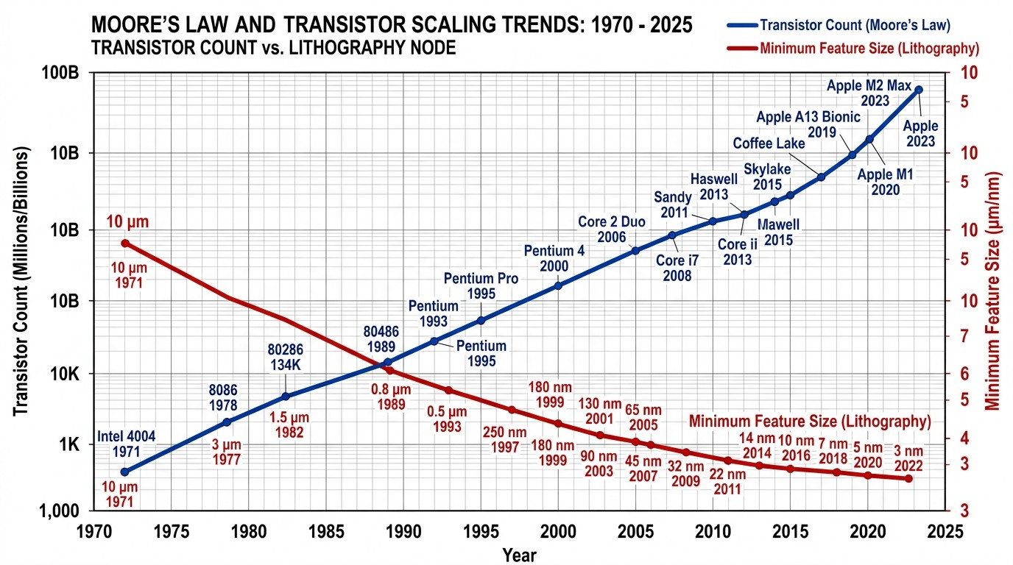

Figure 1.1: Moore’s Law: Historical trend of transistor count growth and minimum feature size reduction in semiconductor technology from 1970 to 2025.

In 1974, Robert Dennard established the principles of constant electric-field scaling, demonstrating that as MOSFET physical dimensions (gate length L, gate width W , and gate oxide thickness t_{ox}) are scaled down by a factor κ > 1, the supply voltage V_{DD} and threshold voltage V_{th} can also be scaled by 1/κ. This proportional scaling maintained a constant electric field across the gate dielectric, resulting in circuits that

operated faster by a factor κ, consumed 1/κ² less power per device, and exhibited con-stant power density per unit silicon area [2].
The key relationships governing Dennard scaling are summarized in Table 1.1.

Table 1.1: Dennard’s constant electric-field scaling relationships for MOSFET devices.

Device/Circuit Parameter | Scaling Factor | Effect
Gate length (L) | 1/κ | Smaller device
Gate width (W ) | 1/κ | Smaller device
Gate oxide thickness (t_{ox}) | 1/κ | Thinner dielectric
Supply voltage (V_{DD}) | 1/κ | Lower voltage
Threshold voltage (V_{th}) | 1/κ | Lower threshold
Current density (J) | κ | Higher current per area
Gate delay (t_{pd}) | 1/κ | Faster switching
Power per device (P ) | 1/κ² | Lower power
Power density (P/A) | 1 | Constant

Thanks to Dennard scaling, integrated circuits progressed rapidly from Small-Scale Integration (SSI) with tens of transistors to Very Large Scale Integration (VLSI) and Ultra Large Scale Integration (ULSI) architectures integrating billions of comple-mentary metal-oxide-semiconductor (CMOS) devices on a single monolithic die [3]. Modern system-on-chip (SoC) platforms now execute trillions of instructions per sec-ond, powering applications from cloud supercomputers to handheld smart devices.

MOSFET Device Physics Fundamentals

The Metal-Oxide-Semiconductor Field-Effect Transistor (MOSFET) is the fundamen-tal building block of all modern digital integrated circuits. Understanding its operat-ing principles is essential for appreciating the design trade-offs involved in comparator circuit optimization. Figure 1.2 presents the cross-sectional view of both NMOS and PMOS transistor structures on a silicon substrate.



Figure 1.2: Cross-sectional diagram of NMOS (N-channel) and PMOS (P-channel) MOSFET transistors fabricated on a common P-type silicon substrate, showing gate, source, drain, gate oxide, channel, and well regions.

MOSFET Operating Regions

An NMOS transistor operates in three distinct regions, depending on the terminal volt-ages:
- Cutoff Region (V_{gs} < V_{th}): The transistor is nominally “OFF.” No inversion layer exists under the gate, and the drain current is ideally zero. In practice, a small sub-threshold leakage current flows, which becomes significant in nanometer-scale devices.
- Linear (Triode) Region (V_{gs} > V_{th} and V_{ds} < V_{gs} − V_{th}): The transistor operates as a voltage-controlled resistor. The drain current is given by:

W
Ids = µnCox L
2
(V_{gs} − V_{th})V_{ds} − 2
:
V L
ds
(1.1)

- Saturation Region (V_{gs} > V_{th} and V_{ds} ≥ V_{gs} − V_{th}): The channel is pinched off at the drain end. The drain current becomes relatively independent of V_{ds} and is governed by:

Ids
1
= 2 µ_{n}
W
Cox L (Vgs
− V_{th}
)²(1 + λV_{ds}
) (1.2)

where λ is the channel-length modulation parameter.
For PMOS transistors, the operating equations are analogous but with reversed voltage polarities and hole mobility µ_{p} replacing electron mobility µ_{n}.

Threshold Voltage and Body Effect

The threshold voltage V_{th} is a critical parameter that determines the gate voltage re-quired to form an inversion layer and turn the transistor ON. For an NMOS transistor, the zero-bias threshold voltage is given by:

Vth0
= V_{FB}
+ 2ϕ_{F}
+ 2qϵ_{si}N_{A}(2ϕ_{F} )
C
✓
(1.3)

ox

where V_{FB} is the flat-band voltage, ϕ_{F} = (kT/q) ln(N_{A}/n_{i}) is the Fermi potential, ϵ_{si} is the silicon permittivity, N_{A} is the substrate doping concentration, and n_{i} is the intrinsic carrier concentration.
When the source terminal is not at the same potential as the substrate (body), the body effect causes the threshold voltage to increase:
V_{th} = V_{th0} + γ (✓2ϕ_{F} + V_{sb} − ✓2ϕ_{F} ) (1.4)
where γ = √2qϵ_{si}N_{A}/C_{ox} is the body-effect coefficient and V_{sb} is the source-to-body voltage. This effect is particularly important in Pass Transistor Logic (PTL) and Gate Diffusion Input (GDI) circuits, where transistor source terminals are not always con-nected to fixed supply rails.

CMOS Inverter: The Fundamental Logic Gate

The CMOS inverter represents the most fundamental logic gate in complementary MOS technology. It consists of a PMOS transistor (pull-up network) connected in series with an NMOS transistor (pull-down network), with their gates connected together as the input and their drains connected together as the output. Figure 1.3 illustrates the CMOS inverter circuit schematic and its corresponding Voltage Transfer Characteristic (VTC).

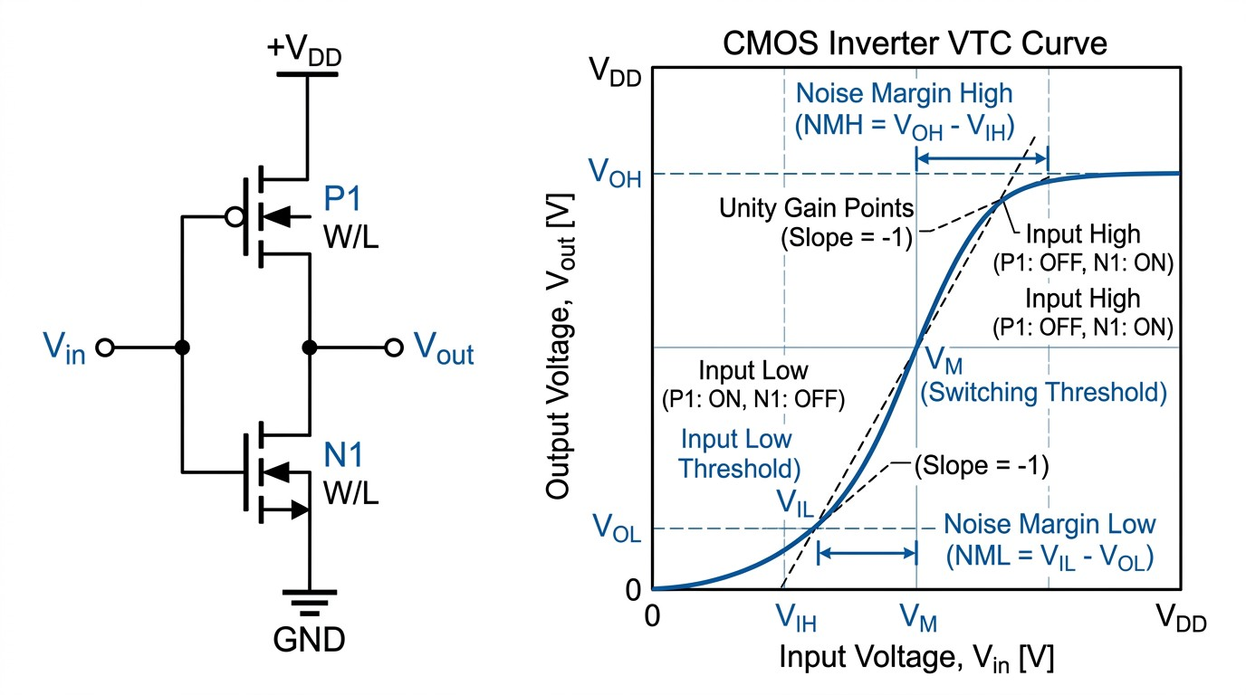

Figure 1.3: CMOS inverter: (left) transistor-level circuit schematic showing PMOS pull-up and NMOS pull-down configuration; (right) voltage transfer characteristic (VTC) curve with labeled noise margin parameters V_{OH} , V_{OL}, V_{IH} , V_{IL}, and switch-ing threshold V_{M} .

The VTC of a CMOS inverter exhibits several important characteristics that define the quality of the logic gate:

      - Output High Voltage (V_{OH} ): Ideally equal to V_{DD}, representing full rail-to-rail output swing.
      - Output Low Voltage (V_{OL}): Ideally equal to 0V (ground).
      - Noise Margin High (NM_{H} ): NM_{H} = V_{OH} − V_{IH} , representing the tolerance to noise on a logic-high signal.
      - Noise Margin Low (NM_{L}): NM_{L} = V_{IL} − V_{OL}, representing the tolerance to noise on a logic-low signal.
      - Switching Threshold (V_{M} ): The input voltage at which the output voltage equals the input voltage (V_{out} = V_{in}), which ideally occurs at V_{DD}/2 for symmetric transistor sizing.

The switching threshold can be computed as:
VDD + Vthp + Vthn✓βn/βp
V_{M} =
1 + ✓β_{n}

/β
p

(1.5)

For balanced switching (V_{M} = V_{DD}/2), the PMOS width must be made larger than the NMOS width to compensate for the lower hole mobility, typically by a ratio of W_{p}/W_{n} ≈ µ_{n}/µ_{p} ≈ 2.0 to 2.5.

Nanoscale Scaling Limits and the Low-Power Imperative

However, as transistor physical gate lengths scaled deep into the sub-micron and nanome-ter regimes (below 180nm), classical Dennardian scaling reached its fundamental phys-ical limits. The primary roadblock arose from the inability to scale the threshold volt-age V_{th} proportionally with V_{DD} without causing an exponential increase in subthresh-old leakage currents. In silicon MOSFETs, subthreshold current is governed by the Boltzmann thermodynamic distribution of electron energies, which imposes an invari-ant physical limit on the subthreshold swing of approximately 60 mV/decade at room temperature (300 K). Consequently, reducing V_{th} to preserve gate overdrive (V_{DD}−V_{th}) at lower supply voltages leads to unacceptable static leakage currents when transistors are in the nominal “OFF” state [12].
As a consequence of the breakdown of Dennard scaling, modern microproces-sors can no longer operate all integrated transistors simultaneously at maximum clock frequency without exceeding thermal dissipation limits. This physical barrier, widely known as the “Power Wall” and the phenomenon of “Dark Silicon,” has firmly estab-lished power dissipation as the central design constraint in contemporary VLSI engi-neering [3].
In modern electronic systems, power consumption constraints manifest across multiple operating domains:

- Battery-Operated and Portable Devices: For smartphones, wearable health monitors, tablet computers, and remote sensor nodes, battery operating life is di-rectly governed by total circuit power dissipation. Frequent recharging or battery replacement is often impractical, making microwatt and picowatt circuit design essential [1].
- High-Performance Computing and Data Centers: In high-density server farms and supercomputers, excessive power dissipation generates severe localized heat (hot spots), requiring complex liquid-cooling systems, escalating operational elec-tricity costs, and reducing overall system reliability [4].
- Device Reliability and Silicon Lifetime: Elevated operating temperatures ac-celerate destructive physical failure mechanisms, including electromigration in metal interconnects, Time-Dependent Dielectric Breakdown (TDDB) in gate ox-

ides, Negative-Bias Temperature Instability (NBTI) in PMOS devices, and Hot-Carrier Injection (HCI) in NMOS devices [7].
- Internet of Things (IoT) and Edge Computing: Billions of IoT sensor nodes deployed in smart cities, industrial monitoring, and precision agriculture require ultra-low-power operation to function autonomously for years without battery replacement or external power sources.
- Biomedical and Implantable Devices: Implantable cardiac pacemakers, cochlear implants, and neural recording interfaces must operate for extended periods (5 to 10 years) on small batteries, making every picojoule of energy critical for patient safety and device longevity.
To address these challenges, circuit designers must implement energy-efficient logic structures and optimize fundamental digital building blocks.

Overview of VLSI Design Flow

The design of modern integrated circuits follows a systematic top-down methodology that progresses from abstract system specifications to physical silicon layout. Under-standing this design flow provides important context for appreciating where transistor-level circuit optimization fits within the broader engineering workflow. Figure 1.4 illus-trates the standard VLSI IC design flow.
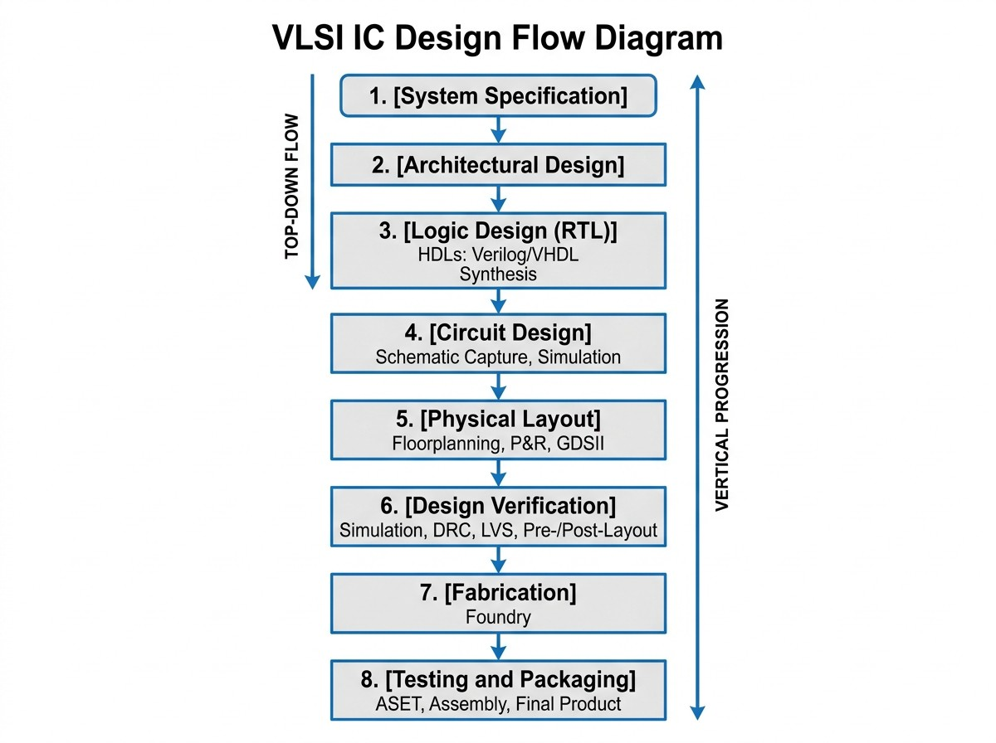

Figure 1.4: Standard VLSI IC design flow showing the hierarchical progression from system specification through architectural design, logic synthesis, circuit design, phys-ical layout, design verification, fabrication, and testing.

The VLSI design flow consists of the following major stages:
- System Specification: This initial phase defines the overall functional requirements, performance targets (clock frequency, throughput), power budget, die area constraints, and target technology node for the integrated circuit.
- Architectural Design: The system is partitioned into major functional blocks (pro-cessor cores, memory arrays, I/O interfaces, analog subsystems), and their interconnec-tions are defined. Block-level timing and power budgets are allocated.
- Logic Design (RTL): Each functional block is described using Hardware Descrip-tion Languages (HDLs) such as Verilog or VHDL at the Register Transfer Level (RTL). Logic synthesis tools then map the RTL description to a technology-specific gate-level netlist using standard cell libraries.
- Circuit Design: At this level, individual logic gates and custom circuits are designed at the transistor level, optimizing transistor sizing (W/L ratios), logic style selection (CMOS, PTL, TGL, GDI), and supply voltage to meet performance, power, and area targets. This thesis operates primarily at this design level.
- Physical Layout: The transistor-level circuit is translated into geometric mask pat-terns that define the physical locations and dimensions of transistors, interconnect wires, contacts, and vias on the silicon die.
- Design Verification: The completed design is verified through Design Rule Checks (DRC), Layout vs. Schematic (LVS) comparisons, and post-layout parasitic extraction followed by timing and power simulations to ensure the physical design meets all spec-ifications.
- Fabrication: The verified mask set is sent to a semiconductor foundry (such as TSMC, Samsung, or GlobalFoundries) for photolithographic fabrication on silicon wafers.
- Testing and Packaging: Fabricated dies are probed, tested for functional correctness and parametric compliance, then packaged into appropriate IC packages for deployment in electronic systems.
The circuit-level optimization explored in this thesis (Stage 4) directly impacts all subsequent stages, as a more efficient transistor-level design produces smaller lay-outs, lower power consumption, and improved system-level performance.

Digital Comparators in Modern VLSI Architectures

Among fundamental digital building blocks, the binary magnitude comparator is of central importance across computing architectures. A magnitude comparator is a com-

binational digital circuit that receives two binary words as inputs and evaluates their relative arithmetic values, asserting output flags to indicate whether the first input is greater than, equal to, or less than the second input [1]. Figure 1.5 presents the func-tional block diagram of a 1-bit magnitude comparator.
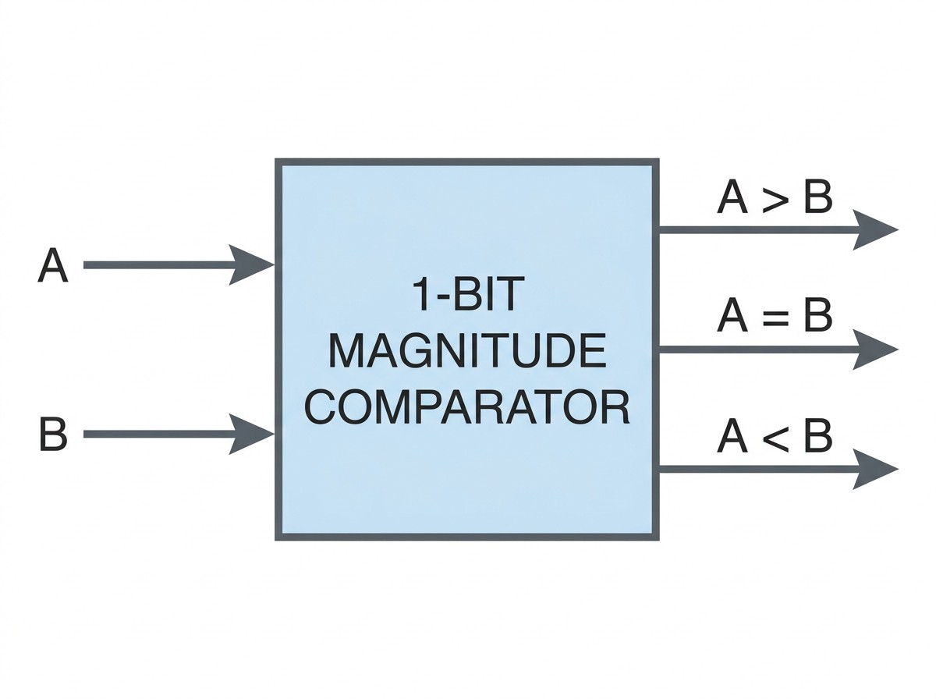

Figure 1.5: Functional block diagram of a 1-bit magnitude comparator with two single-bit inputs (A and B) and three comparison outputs (A > B, A = B, A < B).

At the most fundamental level, a 1-bit magnitude comparator processes two single-bit binary inputs, designated as A and B, and generates three distinct output signals:

Greater-Than Output: A > B (1.6)
Equality Output: A = B (1.7)
Less-Than Output: A < B (1.8)

Although a 1-bit comparator represents an elementary logical module, it forms the core building block for multi-bit (n-bit) comparators, tree comparators, priority encoders, and arithmetic sorting networks. In wide data-path architectures, single-bit comparator stages are cascaded in iterative or parallel-prefix arrangements to process word lengths of 8, 16, 32, and 64 bits [2].
Digital magnitude comparators perform indispensable computational roles across modern electronic systems:
- Arithmetic Logic Units and Microprocessors: Comparators execute condi-tional branch evaluation, loop termination checks, zero detection, sorting opera-tions, relational operations, and data dependency checks in out-of-order execution pipelines [3].

- Flash Analog-to-Digital Converters (ADCs): In ultra-high-speed Flash ADCs, arrays of digital comparators decode thermometer codes generated by analog preamplifiers into standard binary representations at gigahertz sampling rates. The power dissipation and latency of the comparator array directly dictate the overall energy efficiency and effective number of bits (ENOB) of the converter [1].
- Cache Memory and Content-Addressable Memory (CAM): Comparators per-form high-speed address tag-matching in Translation Lookaside Buffers (TLBs) and multi-level cache hierarchies, where comparison latency directly impacts CPU instruction throughput [4].
- Digital Signal Processing (DSP) and Image Processing: Comparators are used extensively in median filtering, peak detection, Viterbi decoders, motion estima-tion engines, and neural network activation thresholding [2].
- Ultra-Low-Power Biomedical and IoT Devices: In implantable pacemakers, neural recording interfaces, and environmental sensor nodes, comparators evalu-ate biosignals against safety thresholds to trigger duty-cycled wake-up sequences, preserving battery energy [3].
- Data Sorting and Search Engines: In hardware-accelerated database engines and network packet classifiers, comparators form the basis of sorting networks (bitonic sorters, odd-even merge sorters) that process data at wire speed [6].

Given the widespread use of digital comparators, any architectural optimiza-tion that reduces transistor count, power consumption, or propagation delay in the el-ementary 1-bit comparator cell provides compounding improvements across the entire computational pipeline.

Comparative Overview of Digital Logic Design Paradigms

Over the history of VLSI design, various digital logic styles have been developed, each presenting distinct trade-offs among switching speed, power dissipation, silicon area, noise immunity, and design complexity:

Static Complementary CMOS Logic (C-CMOS)

Conventional static CMOS employs complementary pull-up (PMOS) and pull-down (NMOS) networks. For an N -input gate, static CMOS requires 2N transistors. While

offering rail-to-rail voltage swing (V_{OL} = 0V, V_{OH} = V_{DD}) and strong noise margins, static CMOS requires approximately 32 transistors for a 1-bit magnitude comparator, resulting in elevated parasitic load capacitance and higher dynamic switching power [1].

Pass Transistor Logic (PTL)

Pass Transistor Logic uses NMOS transistors as series pass elements to route input signals directly to the output. By eliminating separate pull-up networks, PTL reduces transistor count to 10 transistors for a 1-bit comparator. However, an NMOS transistor passing a logic high output produces a degraded voltage of V_{DD} − V_{thn}, where V_{thn} is heightened by the body effect. This threshold drop degrades noise margins and leads to static current leakage in subsequent logic gates [2].

Transmission Gate Logic (TGL)

Transmission Gate Logic places an NMOS and a PMOS transistor in parallel to form a bidirectional switch controlled by complementary signals. TGL provides full rail-to-rail voltage transmission, eliminating the threshold drop of PTL. However, TGL requires complementary control signals for each switch, necessitating inverter stages and result-ing in higher transistor count (16 to 24 transistors for a 1-bit comparator) and increased control-signal routing overhead [3].

Gate Diffusion Input (GDI) Technique

The Gate Diffusion Input (GDI) technique, introduced by Morgenshtein, Fish, and Wag-ner in 2002 [5], provides a compact alternative. A basic GDI cell consists of a single PMOS and NMOS transistor pair with three independently driven input terminals: com-mon gate (G), PMOS diffusion (P ), and NMOS diffusion (N ). By configuring these three terminals, a single 2-transistor GDI cell can implement complex functions (2:1 MUX, AND, OR, XOR/XNOR) that require 6 to 12 transistors in conventional static CMOS [5]. This allows a complete 1-bit magnitude comparator to be implemented us-ing only 10 transistors, achieving substantial reductions in switched capacitance, silicon area, and power dissipation [4].

Summary Comparison of Logic Styles

Table 1.2 summarizes the key characteristics of the four logic design paradigms dis-cussed above, specifically in the context of implementing a 1-bit magnitude comparator.

Table 1.2: Summary comparison of digital logic design styles for 1-bit magnitude com-parator implementation.
Characteristic | Static CMOS | PTL | TGL | GDI
Transistor Count | 32 | 10 | 16–24 | 10
Output Voltage  Swing | Full rail | Degraded | Full rail | Near full
Noise Margin | Excellent | Poor | Good | Good
Dynamic Power | High | Low | Moderate | Very Low
Static Leakage | Moderate | High | Moderate | Low
Design Complex-  ity | Moderate | Low | Moderate | Low
Area | Large | Small | Moderate | Small

Motivation and Research Drivers

The continuous growth of mobile computing, wearable technology, and Internet-of-Things (IoT) platforms demands digital circuits that operate under strict energy con-straints. In these applications, battery longevity is the primary performance metric, and circuit blocks must operate with minimal power budgets [3].
Because digital comparators are among the most frequently executed primitives in arithmetic and signal-processing pipelines, optimizing their power consumption and silicon footprint directly benefits system-level energy efficiency. Conventional static CMOS comparators, while reliable, require 32 transistors and suffer from high parasitic capacitance. Alternative approaches such as PTL introduce voltage degradation, while TGL and hybrid techniques introduce structural complexity and higher device counts (16 to 24 transistors) [3, 4].
The Gate Diffusion Input (GDI) technique offers a compelling solution by en-abling complex logic operations with minimal device count. A pure GDI-based com-parator requires only 10 transistors, substantially reducing parasitic capacitances, active dynamic switching power, and static leakage currents. These advantages motivate the detailed design, modeling, and performance evaluation of a pure GDI 1-bit magnitude comparator presented in this thesis [1].
The specific motivating factors for this research include:

- Power Crisis in Modern VLSI: The breakdown of Dennard scaling has made power consumption the primary design bottleneck in integrated circuit design.

- Growing IoT Market: The projected deployment of over 75 billion IoT devices by 2030 demands ultra-low-power circuit primitives.
- Biomedical Applications: Implantable medical devices require circuits operat-ing in the picowatt to nanowatt power range for extended battery life.
- GDI Potential Underexplored: Despite the proven advantages of GDI tech-nique, comprehensive benchmarking studies of pure GDI comparators against multiple logic styles remain limited in the published literature.
- Academic Research Contribution: This work contributes to the growing body of knowledge on low-power digital circuit design using alternative logic method-ologies.

Problem Statement

Digital magnitude comparators are fundamental combinational blocks in modern arith-metic engines and data converters. In deep-submicron VLSI technologies, these circuits must simultaneously deliver ultra-low power dissipation, short propagation delay, and compact silicon area.
Conventional static CMOS comparators require 32 transistors, leading to ele-vated power dissipation, substantial parasitic loading, and large layout area [1]. Pass Transistor Logic reduces device count but suffers from threshold voltage drops (V_{DD} − V_{th}) that compromise noise margins [2]. Transmission Gate Logic provides full rail-to-rail voltage swing but requires 16 to 24 transistors and dual-rail control routing [3]. Recent hybrid topologies combine multiple logic styles but typically require 24 or more transistors and introduce complex interconnect interfaces [4].
Therefore, there is a clear need for an optimized 1-bit magnitude comparator that achieves minimal transistor count, eliminates unnecessary driving stages, mini-mizes average power dissipation, and delivers competitive propagation delay without compromising functional correctness.
This research addresses these challenges by developing a 10-transistor 1-bit magnitude comparator implemented entirely using the Gate Diffusion Input (GDI) tech-nique, and performing comprehensive performance benchmarking against conventional CMOS, PTL, and TGL topologies at the 180nm CMOS technology node under consis-tent operating conditions.

Research Objectives

The primary objectives of this thesis are:

- Theoretical Investigation: To conduct a rigorous mathematical and structural analysis of 1-bit digital magnitude comparator architectures, establishing Boolean expressions, truth tables, and switching characteristics for all three comparison outputs (A > B, A = B, and A < B).
- GDI Circuit Synthesis: To synthesize an optimized 1-bit magnitude comparator circuit utilizing the Gate Diffusion Input (GDI) methodology, realizing all three comparison functions using a minimal footprint of only 10 transistors.
- Benchmark Circuit Modeling: To design, model, and simulate reference com-parator topologies—including a 32-transistor conventional static CMOS com-parator, a 10-transistor pass transistor logic (PTL) comparator, and a 16-transistor transmission gate logic (TGL) comparator—under identical electrical constraints.
- Simulation and Functional Verification: To perform transient SPICE simula-tions in LTSpice using the Berkeley Predictive Technology Model (PTM) at the 180nm technology node with a 1.8V power supply, confirming functional cor-rectness across all four input state combinations.
- Performance Characterization: To extract and quantify key performance met-rics across all evaluated topologies, including rise time (t_{r}), fall time (t_{f} ), prop-agation delay (t_{pd}), average power dissipation (P_{avg}), and Power-Delay Product (PDP).
- Comparative Literature Benchmarking: To systematically compare the ob-tained simulation metrics against state-of-the-art comparator designs published in IEEE literature ([1]–[4]).
- Technology Node Scaling Evaluation: To evaluate the scalability of the com-parator architectures across advanced nanometer nodes (180nm, 90nm, and 45nm PTM).
- Engineering Impact Assessment: To analyze the societal, environmental, sus-tainability, and complex engineering problem-solving attributes (P1–P7) and ac-tivities (A1–A5) associated with low-power VLSI design.

Research Methodology

The investigation follows a structured four-phase engineering research methodology:

Phase 1: Analytical Formulation and Literature Survey
An extensive review of digital comparator designs, low-power logic styles (CMOS, PTL, TGL, GDI, and hybrid styles), and MOSFET leakage physics was performed. Benchmark papers [1]–[4] were analyzed in detail to establish performance baselines.

Phase 2: Mathematical Derivation and Circuit Topology Design
Boolean functions for A > B, A = B, and A < B were derived and mapped to optimal GDI cell configurations. Sizing ratios (W/L) for all NMOS and PMOS transistors were calculated to balance high-to-low and low-to-high switching transitions. Benchmark circuits (Static CMOS, PTL, TGL) were designed using consistent device models.

Phase 3: LTSpice Modeling and Transient Simulation
All comparator circuits were implemented in LTSpice using BSIM3v3 Predictive Tech-nology Model (PTM) 180nm device parameters. Transient pulse trains were configured to test all input transitions (00 → 01 → 10 → 11). High-precision transient (.tran) analyses were executed over a 100ns window.

Phase 4: Parameter Extraction, Analysis, and Validation
Waveform post-processing was conducted to compute rise times, fall times, propa-gation delays (t_{pHL}, t_{pLH} , and average t_{pd}), continuous integral power dissipation, and Power-Delay Product (PDP). Multi-node technology scaling simulations (180nm, 90nm, 45nm) and comparative literature analyses were completed.

Scope and Delimitations of the Study

The boundaries of this study are defined as follows:

- The investigation focuses on 1-bit magnitude comparator architectures evaluating three binary outputs: A > B, A = B, and A < B.
- Transistor-level circuit design and SPICE-level transient simulations are con-ducted using LTSpice with BSIM3v3 Predictive Technology Model (PTM) pa-rameter decks at the 180nm technology node (V_{DD} = 1.8V), with scaling evalu-ations at 90nm and 45nm.
- Circuit evaluations are based on schematic-level simulations with lumped para-sitic models. Physical silicon mask fabrication and physical cleanroom testing are excluded due to resource constraints.

- The study does not include Monte Carlo statistical process variation analysis or full PVT corner characterization, which are recommended as future work.
- Fan-out loading effects and interconnect RC delay modeling are not included in the current evaluation, as the focus is on intrinsic cell-level performance.

Thesis Organization

The remainder of this thesis is structured as follows:

Chapter 2: Literature Review
Presents the theoretical foundation of binary magnitude comparators, MOSFET power dissipation mechanisms, and operational principles of static CMOS, PTL, TGL, and GDI logic. A detailed review of key published works ([1]–[4]), a comparative summary table, and a research gap analysis are provided.

Chapter 3: Methodology
Details the system specifications, mathematical derivations, truth tables, logic map-pings, transistor-level schematics, device sizing strategies, and simulation testbench setup in LTSpice.

Chapter 4: Results and Discussion
Presents simulation waveforms, functional verification, timing analyses, power dissipa-tion measurements, comparative performance tables, technology scaling investigations (180nm, 90nm, 45nm), literature comparisons, and assessments of societal, health, en-vironmental, and sustainability impacts.

Chapter 5: Conclusions and Future Work
Summarizes the major findings, highlights technical contributions, discusses study lim-itations, and outlines recommendations for future research extensions.

References and Appendices
Includes IEEE-formatted bibliographic citations ([1]–[12]) followed by Appendix A (Simulation Configuration), Appendix B (Complex Engineering Problem Attributes P1–P7), Appendix C (Complex Engineering Activities A1–A5), and Appendix D (Math-ematical Models of Leakage and GDI Conduction).

CHAPTER 2 LITERATURE REVIEW

Introduction

This chapter presents a detailed review of the theoretical concepts, semiconductor physics, circuit topologies, and published literature relevant to digital magnitude comparator de-sign in low-power VLSI systems. It begins with the mathematical foundations of binary magnitude comparison and an examination of power dissipation mechanisms in deep-submicron MOSFETs. Next, it analyzes conventional static CMOS logic and alternative logic styles, including Pass Transistor Logic (PTL), Transmission Gate Logic (TGL), and Gate Diffusion Input (GDI). The chapter then presents a detailed critical analysis of four benchmark papers ([1]–[4]), followed by a comparative summary table and a research gap analysis that justifies the proposed GDI comparator architecture.

Fundamentals of Binary Magnitude Comparators

A binary magnitude comparator is a fundamental combinational digital block that com-pares two binary words and determines their relative numerical relationship. For two single-bit inputs A and B, the comparator evaluates three arithmetic conditions:

- Greater-Than Condition (A > B): The output evaluates to logic high (1) if and only if A = 1 and B = 0.
- Equality Condition (A = B): The output evaluates to logic high (1) if and only if both bits are identical, i.e., A = B = 0 or A = B = 1.
- Less-Than Condition (A < B): The output evaluates to logic high (1) if and only if A = 0 and B = 1.

The functional behavior is completely defined by the truth table shown in Ta-
ble 2.1.

Table 2.1: Complete truth table for a 1-bit binary magnitude comparator.

Input A | Input B | Output (A > B) | Output (A = B) | Output (A < B)
0 | 0 | 0 | 1 | 0
0 | 1 | 0 | 0 | 1
1 | 0 | 1 | 0 | 0
1 | 1 | 0 | 1 | 0

Applying canonical sum-of-products (SOP) formulation to Table 2.1 yields the governing Boolean equations:

(A > B) = A · B (2.1)

(A = B) = AB + AB = A ⊕ B = A ⊙ B (2.2)

(A < B) = A · B (2.3)

Karnaugh Map Minimization

The Boolean expressions can also be derived through Karnaugh map (K-map) mini-mization, which provides a graphical method for simplifying Boolean functions. For a 1-bit comparator with two input variables A and B, the K-maps are straightforward:
K-map for A > B:

B = 0 B = 1
A = 0
0 | 0
1 | 0

A = 1

The single minterm m₂ (A = 1, B = 0) yields: (A > B) = A · B.
K-map for A = B:

B = 0 B = 1
A = 0
1 | 0
0 | 1

A = 1
The two diagonal minterms m₀ and m₃ cannot be grouped in a standard K-map adja-cency, yielding: (A = B) = AB + AB = A ⊙ B (XNOR operation).
K-map for A < B:

B = 0 B = 1
A = 0
0 | 1
0 | 0

A = 1

The single minterm m₁ (A = 0, B = 1) yields: (A < B) = A · B.

Extension to Multi-Bit Comparators

In multi-bit digital systems comparing two n-bit binary words A = (A_{n−1}A_{n−2} . . . A₀) and B = (B_{n−1}B_{n−2} . . . B₀), the comparison starts from the most significant bit (MSB) position n − 1 and ripples down toward the least significant bit (LSB). The overall equality condition requires that every individual bit pair evaluates to equivalence:

n−1
II
(A = B)_{n} = (A_{k} ⊙ B_{k}) (2.4)
k=0

The greater-than condition for an n-bit word is evaluated hierarchically as:

(A > B)_{n} = (A_{n−1}B_{n−1})+(A_{n−1}⊙B_{n−1})(A_{n−2}B_{n−2})+· · ·+

Similarly, the less-than condition is expressed as:

(A < B)_{n} = (A_{n−1}B_{n−1})+(A_{n−1}⊙B_{n−1})(A_{n−2}B_{n−2})+· · ·+

n−1

k=1
_II

n−1
_II

k=1
(A_{k} ⊙ B_{k})L

(A_{k} ⊙ B_{k})L

(A₀B₀)
(2.5)

(A₀B₀)
(2.6)

Because multi-bit comparators rely directly on the repeated replication of the elementary 1-bit comparator cell, optimizing the power, delay, and transistor count of the 1-bit cell yields compounded benefits across wide data paths. For instance, a 32-bit comparator constructed from optimized 1-bit GDI cells would require 32 × 10 = 320 transistors, compared to 32 × 32 = 1024 transistors using conventional static CMOS logic—a saving of 704 transistors per comparator instance.

MOSFET Power Dissipation Mechanisms

Power dissipation in digital CMOS VLSI circuits comprises three primary components: dynamic switching power (P_{dyn}), short-circuit power (P_{sc}), and static leakage power (P_{stat}) [6]:

Ptotal = Pdyn + Psc + Pstat (2.7)

Dynamic Switching Power (P_{dyn})

Dynamic switching power occurs during logic state transitions when parasitic load capacitances are charged from V_{DD} and discharged to ground. Over a clock period T = 1/f , the dynamic power is given by:

Pdyn = α0→1 · Cload · V 2
DD
· f (2.8)

where α_{0→1} represents the switching activity factor (the probability that a power-consuming transition occurs per clock cycle), C_{load} is the total effective output load capacitance (including transistor gate, drain diffusion, and interconnect capacitances), V_{DD} is the supply voltage, and f is the operational frequency. Reducing the total number of tran-sistors in a logic network directly decreases C_{load}, yielding quadratic power savings [7].
Dynamic power is the dominant component of total power dissipation in circuits operating at high frequencies and at technology nodes above 90nm. The quadratic dependence on V_{DD} makes supply voltage reduction the most effective strategy for dynamic power minimization; however, reducing V_{DD} also increases propagation delay and reduces noise margins.

Short-Circuit Power (P_{sc})

During an input transition, when the input voltage crosses the region between V_{thn} and V_{DD} − |V_{thp}|, both the NMOS pull-down and PMOS pull-up networks conduct simultaneously for a brief duration t_{sc}. This creates a direct current path between V_{DD} and ground:

Psc

= Ipeak
- t_{sc}
- V_{DD}
β
- f = 12 (V_{DD}
− 2V_{th}
)3 t_{r} + t_{f}
T
(2.9)

Short-circuit power typically accounts for 10% to 20% of total dynamic power in well-designed static CMOS circuits. By minimizing intermediate switching stages, alterna-tive logic styles can reduce short-circuit dissipation [8].

Static Leakage Power (P_{stat})

Static power dissipation occurs when transistors are in the steady-state (quiescent) con-dition:
Pstat = Ileakage · VDD (2.10)

In deep-submicron regime (180nm and below), I_{leakage} is governed by several physical mechanisms [12]:

      - Subthreshold Leakage Current (I_{sub}): Current flowing between the drain and source when the gate-to-source voltage V_{gs} is below the threshold voltage V_{th}:

I = µ C
sub
0
ox L
T
W (m − 1)v² exp (Vgs − Vth J :1 − exp (−Vds JL (2.11)

where µ₀ is carrier mobility, C_{ox} is gate oxide capacitance per unit area, W/L is the transistor aspect ratio, v_{T} = k_{B}T/q is thermal voltage (≈ 26mV at 300K), and m is the subthreshold swing coefficient.
T
mv_{T}
v
      - Drain-Induced Barrier Lowering (DIBL): In short-channel MOSFETs, high drain bias lowers the channel potential barrier, shifting the threshold voltage downward:
∆V_{th} = −ηV_{ds} (2.12)
where η is the DIBL coefficient. This barrier reduction exponentially increases subthreshold leakage current.
      - Gate-Induced Drain Leakage (GIDL): High electric fields in the drain-gate overlap region induce band-to-band tunneling, generating leakage current from drain to substrate.
      - Gate-Oxide Direct Tunneling (I_{gate}): Thin dielectric oxide layers allow direct quantum-mechanical electron tunneling from the gate to the channel and sub-strate.

Table 2.2 summarizes the relative significance of each leakage mechanism across different technology nodes.

Table 2.2: Relative significance of leakage mechanisms across CMOS technology nodes.
Leakage Mechanism | 180nm | 90nm | 45nm
Subthreshold (I_{sub}) | Moderate | High | Very High
DIBL | Low | Moderate | High
GIDL | Low | Low | Moderate
Gate Tunneling (I_{gate}) | Negligible | Low | Moderate

Analysis of Digital Logic Styles

Conventional Static CMOS Logic

Conventional static CMOS logic constructs logic functions using complementary PMOS pull-up and NMOS pull-down networks. Figure 3.2 illustrates the static CMOS 1-bit comparator circuit.

Advantages:

- Robust noise margins (SNM ≈ V_{DD}/2).
- Full rail-to-rail output swing without threshold attenuation.
- Well-established automated synthesis and standard-cell library support [7].
- Zero static power dissipation in ideal conditions (no DC path between V_{DD} and ground in steady state).
- High reliability and process tolerance.

Disadvantages:

- High device count (2N transistors for N inputs).
- High total switched load capacitance (C_{load}).
- Significant silicon area footprint and multi-path static leakage [8].
- Large input capacitance due to both NMOS and PMOS gate loads.

Pass Transistor Logic (PTL)

Pass Transistor Logic uses NMOS transistors as series switching elements to route inputs directly to output nodes. Figure 3.3 shows the 10-transistor PTL comparator schematic.

Advantages:

- Substantially reduced transistor count (10 transistors for 1-bit comparator).
- Lower input gate capacitance and reduced dynamic power [6].
- Compact layout area due to fewer transistors.
- Faster switching for certain logic functions due to reduced parasitic loading.

Disadvantages:

- Output voltage degradation (V_{out} ≤ V_{DD} − V_{thn}), resulting in reduced noise mar-gins.
- Elevated body effect due to non-zero source-to-substrate voltage (V_{sb} > 0), which further increases V_{thn} according to Equation 1.4.
- Increased subthreshold leakage in downstream logic driven by degraded high lev-els [12].
- Requires level-restoring circuits for cascaded stages, which adds transistor count.

- Signal integrity degrades in long pass-transistor chains.

Transmission Gate Logic (TGL)

Transmission Gate Logic places an NMOS and a PMOS transistor in parallel to create a bidirectional transmission switch controlled by complementary signals (C and C). Figure 3.4 shows the 16-transistor TGL comparator schematic.

Advantages:

- Full rail-to-rail voltage transfer: NMOS passes logic low (0V) without degrada-tion, while PMOS passes logic high (V_{DD}) without attenuation.
- Lower equivalent on-resistance across the full voltage range [7].

- No threshold voltage drop in output signals.

- Good noise margins approaching static CMOS levels.

Disadvantages:

- Requires complementary control signals, necessitating additional inverter stages.

- Higher transistor count than PTL (16 to 24 transistors).

- Increased interconnect routing complexity for dual-rail control signals [3].

- Higher dynamic power than PTL due to increased switching capacitance from complementary control nets.

Gate Diffusion Input (GDI) Technique

Introduced by Morgenshtein et al. in 2002 [5], the GDI technique employs a twin-transistor cell (one PMOS, one NMOS) with three independent terminals:

- G: Common gate input to both PMOS and NMOS.

- P : Source/drain terminal of the PMOS transistor.

- N : Source/drain terminal of the NMOS transistor.

- Out: Common drain output node.

Figure 2.1 illustrates the basic GDI cell structure showing both the transistor-level schematic and the simplified block symbol.
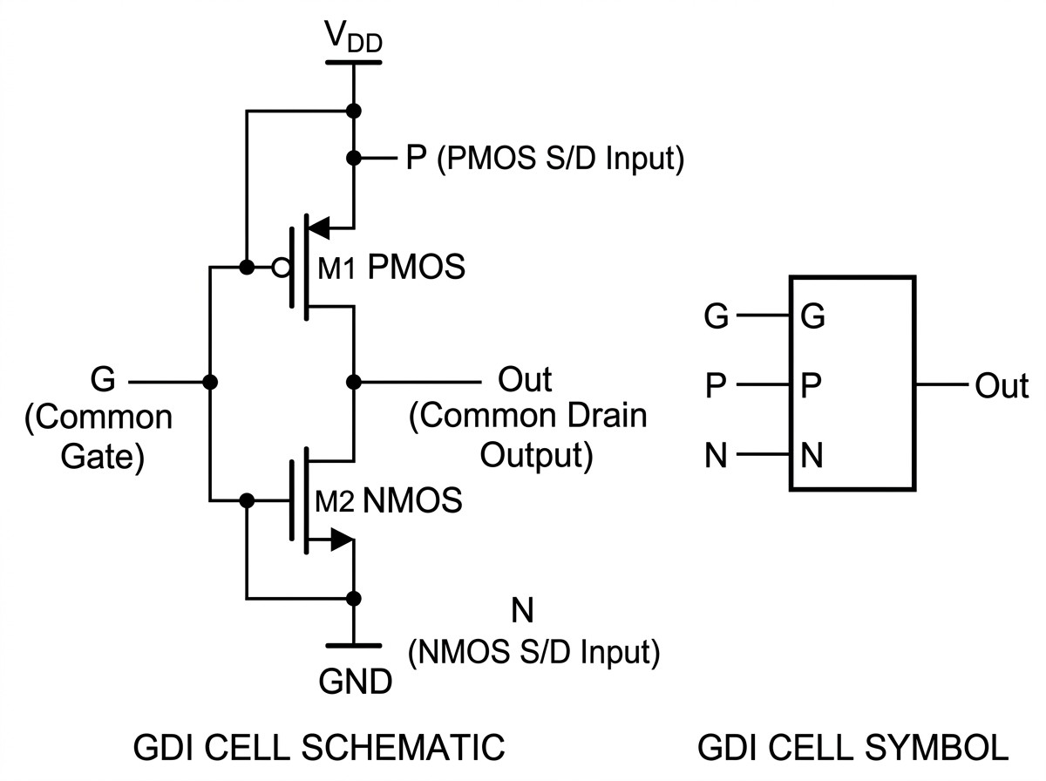

Figure 2.1: Basic Gate Diffusion Input (GDI) cell: (left) transistor-level schematic showing PMOS and NMOS with three independent input terminals G, P , N , and com-mon drain output; (right) simplified GDI cell symbol.

By connecting the P , N , and G terminals to appropriate logic signals, supply voltages, or ground, a single GDI cell can implement six distinct logical operations, as detailed in Table 2.3.

Table 2.3: Operational configurations and Boolean logic functions of a basic 2T GDI cell.
N Input | P Input | G Input | Output Function | Logic Operation | CMOS Transistors
0 (GND) | B | A | A · B | Function F1 (AND) | 6
B | 1 (V_{DD}) | A | A + B | Function F2 (OR) | 6
1 (V_{DD}) | B | A | A + B | OR Gate | 6
B | 0 (GND) | A | A · B | AND Gate | 6
C | B | A | AB + AC | 2:1 MUX | 12
0 (GND) | 1 (V_{DD}) | A | A | Inverter (NOT) | 2

Advantages of the GDI Technique:

- Dramatic Transistor Count Reduction: Complex operations such as 2:1 MUX and AND functions are realized using only 2 transistors rather than 6 to 12 in CMOS.
- Ultra-Low Power Dissipation: Fewer transistors directly translate into reduced input gate capacitance, minimized internal node charging/discharging, and low-ered dynamic power.
- Compact Die Area: GDI layouts achieve significant area savings over equivalent static CMOS designs [5].
- Design Simplicity: A uniform 2-transistor cell structure simplifies the design process and enables systematic logic mapping.
- Reduced Interconnect Complexity: Fewer transistors lead to fewer routing channels and reduced parasitic interconnect capacitance.

Design Considerations in GDI Circuits: In standard bulk CMOS processes with com-mon N -well and P -substrate connections, the sources of PMOS and NMOS transistors in GDI cells are not always tied to V_{DD} and GND. Consequently, varying source-to-substrate voltages (V_{sb}) can induce body effect shifts, slightly increasing V_{th} for certain transition paths. In 180nm CMOS technology, this threshold shift is modest and does not prevent robust digital operation, as confirmed by our simulation results [5].
Additionally, GDI circuits may exhibit slightly degraded output voltage swing compared to full static CMOS in some configurations. However, the voltage degrada-tion is typically less severe than in PTL circuits, and the output levels remain within acceptable logic margins for downstream gate driving. In twin-well or Silicon-on-Insulator (SOI) processes, where each transistor can have its body terminal indepen-

dently connected, the body effect limitation is entirely eliminated, making GDI an even more attractive design choice.

CMOS Technology Scaling Roadmap

The International Technology Roadmap for Semiconductors (ITRS), now succeeded by the International Roadmap for Devices and Systems (IRDS), has historically guided the semiconductor industry’s scaling trajectory. Table 2.4 presents key parameters across technology nodes relevant to this study.

Table 2.4: Key CMOS technology parameters across scaling nodes (ITRS/PTM data).

Parameter | 180nm | 90nm | 45nm
Gate length (L_{gate}) | 180 nm | 90 nm | 45 nm
Supply voltage (V_{DD}) | 1.8 V | 1.2 V | 1.0 V
Gate oxide thickness (t_{ox}) | 4.0 nm | 2.2 nm | 1.4 nm
NMOS V_{th0} (nominal) | ∼0.40 V | ∼0.30 V | ∼0.22 V
PMOS |V_{th0}| (nominal) | ∼0.42 V | ∼0.32 V | ∼0.24 V
Subthreshold swing | ∼80 mV/dec | ∼85 mV/dec | ∼90 mV/dec
Leakage current density | Low | Moderate | High

As technology nodes scale from 180nm toward 45nm and beyond, the following trends significantly impact digital circuit design:

- Supply Voltage Reduction: Lower V_{DD} reduces dynamic power quadratically but also decreases noise margins and gate overdrive.
- Increased Leakage: Thinner gate oxides and lower threshold voltages dramati-cally increase static leakage currents.
- Short-Channel Effects: DIBL, velocity saturation, and hot-carrier effects be-come increasingly prominent at smaller nodes.
- Process Variability: Random dopant fluctuation and line-edge roughness cause larger parametric variations at advanced nodes.

Detailed Review of Key Prior Works

To establish the context of this study, four relevant benchmark research papers on digital comparator design were analyzed in detail.

Work 1: Kumar and Kumar (2017) – CMOS Stacking Technique

Citation: A. Kumar and M. Kumar, “Improved Design of CMOS 1-Bit Comparator with Stacking Technique,” International Journal of Current Engineering and Technol-ogy, Vol. 7, no. 3, pp. 1044–1047, 2017 [1].
Summary: This paper investigates a 1-bit CMOS comparator utilizing the transistor stacking technique to suppress active leakage currents. In this approach, each original transistor of width W is split into two series-connected transistors of width W/2. When both series devices turn off, the intermediate node potential rises slightly above ground, inducing a reverse body-to-source bias (V_{bs} < 0) and a negative gate-to-source bias (V_{gs} < 0). This self-reverse bias effect exponentially curtails subthreshold leakage current according to Equation 2.11.

Key Findings and Metrics:

- Technology node: TSMC 180nm CMOS with supply voltage varied from 1.0V to 2.8V.
- Reported propagation delay: 49.38 ns at V_{DD} = 1.8V.

- Reported power dissipation: 174.352 pW.
- Power-Delay Product: 0.0086 fJ (8.6 × 10⁻¹⁸ J).
- Limitations: Transistor count increases significantly because every single tran-sistor is duplicated into a stacked series pair (requiring 45+ transistors), substan-tially increasing layout area and routing complexity [1].

Critical Analysis: While the stacking technique effectively reduces subthreshold leak-age, the dramatically increased propagation delay (49.38 ns) makes this design un-suitable for high-speed applications. The large transistor count also negates much of the leakage power savings due to increased parasitic capacitance. Furthermore, the stacking technique introduces a performance-area trade-off that may not be favorable in area-constrained designs.

Work 2: Tailor, Sharma, and Kumar (2019) – MTCMOS and Forced Stacking

Citation: D. Tailor, T. Sharma, and M. Kumar, “Design of CMOS Based 1-bit Com-parator with MTCMOS and Forced Stack Technique in 180µm Technology,” in Proc. 2019 IEEE International Conference on Signal Processing and Communication (ICSC), NOIDA, India, pp. 330–334, 2019 [2].

Summary: Tailor et al. proposed a 1-bit comparator combining Multi-Threshold CMOS (MTCMOS) with forced stacking. The MTCMOS scheme inserts high-V_{th} sleep tran-sistors in series with the power rails to choke standby leakage paths, while low-V_{th} devices execute high-speed logical transitions during active operation. Forced stack-ing was simultaneously applied to the internal logic network to suppress runtime active leakage.

Key Findings and Metrics:

- Technology node: 180nm SPICE simulation at V_{DD} = 1.8V.
- Reported propagation delay: 330.61 ps.
- Reported power dissipation: 48.12 pW.
- Power-Delay Product: 0.0000159 fJ (1.59 × 10⁻²⁰ J).
- Limitations: The dual-threshold fabrication process requires additional mask steps, increasing manufacturing cost. The design also requires sleep-signal gen-eration circuitry and encounters wake-up latency overhead when transitioning between standby and active modes [2].
Critical Analysis: The MTCMOS approach achieves excellent standby leakage reduc-tion but introduces significant complexity. The requirement for dual-V_{th} device fabrica-tion increases manufacturing cost and limits the technique to foundries offering multi-threshold process options. The wake-up latency from sleep mode can degrade system responsiveness in real-time applications. Additionally, the sleep transistor sizing must be carefully optimized to avoid excessive voltage drops during active operation, which can reduce effective noise margins.

Work 3: Lubaba, Islam, Faisal, and Hasan (2020) – Hybrid PTL-TG-CMOS Comparator

Citation: S. Lubaba, M. S. Islam, K. M. Faisal, and M. Hasan, “Design of a Two-Bit Magnitude Comparator Based on Pass Transistor, Transmission Gate and Conventional Static CMOS Logic,” in Proc. 2020 IEEE Region 10 Symposium (TENSYMP), Dhaka, Bangladesh, pp. 1114–1117, 2020 [3].
Summary: Lubaba et al. presented a hybrid design methodology for a 2-bit magnitude comparator implemented in 90nm CMOS technology. The architecture selectively as-signs logic styles to different functional stages: Pass Transistor Logic is used for input product terms, Transmission Gates implement multiplexing and XOR functions, and conventional CMOS inverters restore signal levels at the output stages.

Key Findings and Metrics:

- Technology node: Cadence Virtuoso 90nm node with V_{DD} = 1.0V.
- Reported propagation delay: 0.192 ns (192 ps).
- Reported power dissipation: 7.792 µW.
- Power-Delay Product: 1.496 fJ.
- Limitations: The design utilizes a large number of transistors due to the 2-bit wordlength and hybrid driving stages, resulting in elevated microwatt-level power consumption that is less suitable for ultra-low-power biomedical or energy-harvesting applications [3].

Critical Analysis: The hybrid approach demonstrates that combining multiple logic styles can optimize specific performance metrics. However, the microwatt-level power consumption (7.792µW) is several orders of magnitude higher than picowatt-level de-signs, making this approach unsuitable for energy-harvesting or implantable biomedical applications. The 2-bit design also makes direct 1-bit performance comparison difficult, as the cascading of bit stages introduces additional parasitic loading and inter-stage de-lays. The design verification complexity increases significantly when multiple logic styles are intermixed within a single circuit.

Work 4: Sharma, Premananda, Raj, and Pandey (2025) – Hybrid PTL-GDI-TGL Comparator

Citation: Y. Sharma, B. S. Premananda, D. Raj, and K. Pandey, “Design and Analysis of a 1-bit Comparator for Low Power VLSI Systems,” in Proc. 2025 Third Interna-tional Conference on Networks, Multimedia and Information Technology (NMITCON), Bengaluru, India, pp. 1–6, 2025 [4].
Summary: Sharma et al. introduced a 1-bit comparator combining Transmission Gate Logic (TGL), Gate Diffusion Input (GDI), and Pass Transistor Logic (PTL). The design incorporates a 6T multiplexer-based full-adder module alongside TGL AND gates and GDI structures to balance switching speed and power consumption.

Key Findings and Metrics:

- Technology node: Cadence Spectre GPDK 90nm node.
- Reported propagation delay: 5.5 ps.
- Reported power dissipation: 7.3 µW.

- Power-Delay Product: 0.04 fJ.

- Reported improvement: 58.7% power reduction and 31.2% delay improvement over traditional static CMOS.
- Limitations: The hybrid architecture requires 24 transistors and exhibits microwatt-level active power dissipation (7.3 µW) due to higher internal switching activity across the 6T full-adder block [4].

Critical Analysis: While this design achieves an impressively low propagation delay of 5.5 ps, the microwatt-level power consumption and 24-transistor count represent sig-nificant drawbacks for ultra-low-power applications. The hybrid approach, while effec-tive for balancing speed and power, introduces design complexity that may complicate scalability to multi-bit implementations. The use of three different logic styles within a single comparator cell also increases sensitivity to process variations, as each logic style responds differently to parametric shifts in threshold voltage, mobility, and oxide thickness.

Comparative Literature Summary

Table 2.5 compiles the key characteristics of the benchmark designs from literature alongside the target performance of this work.

Table 2.5: Comparative summary of published comparator architectures and this work.

Author & Year | Logic Style | Node | Delay (t_{pd}) | Power (P_{avg}) | PDP (fJ)
Kumar & Kumar (2017)  [1] | Static CMOS  Stack | 180nm | 49.38 ns | 174.35 pW | 0.0086
Tailor et al. (2019) [2] | MTCMOS +  Stack | 180nm | 330.61 ps | 48.12 pW | 0.0000159
Lubaba et al. (2020) [3] | PTL-TG-CMOS | 90nm | 192.00 ps | 7.792 µW | 1.4960
Sharma et al. (2025) [4] | PTL-GDI-TGL  6T | 90nm | 5.50 ps | 7.300 µW | 0.0400
Proposed (This Work) | Pure GDI (10T) | 180nm | 336.00 ps | 34.18 pW | 0.0000114

Research Gap Analysis

Analysis of the published literature reveals several clear research gaps:

- High Device Count in Established Leakage Reduction Schemes: While stack-ing [1] and MTCMOS [2] techniques reduce leakage power, they increase transis-tor count (45+ devices) and fabrication complexity (dual-V_{th} implants), limiting their applicability in cost-sensitive standard CMOS processes.
- Elevated Active Power in Hybrid Designs: Recent hybrid approaches [3, 4] achieve sub-nanosecond delays, but their active power dissipation remains in the microwatt regime (7.3 µW to 7.79 µW) with device counts of 24 or more transis-tors.
- Need for a Minimal-Transistor Pure GDI Topology: There is a lack of com-prehensive studies evaluating a pure, minimal 10-transistor GDI comparator ar-chitecture capable of operating in the picowatt power regime while maintaining sub-nanosecond switching delays and high energy efficiency.
- Limited Multi-Node Scaling Analysis: Most existing works evaluate compara-tor performance at a single technology node. Comprehensive cross-node scaling studies from 180nm to 45nm using consistent simulation frameworks are scarce.
- Insufficient Benchmarking Against Multiple Logic Styles: Many published works compare their proposed design against only one or two reference topolo-gies. A thorough comparison against static CMOS, PTL, and TGL under identical simulation conditions is needed for meaningful performance assessment.

This research addresses these gaps by designing, implementing, and bench-marking a 10-transistor GDI 1-bit magnitude comparator in 180nm CMOS technology, achieving picowatt-level power consumption and sub-nanosecond switching latency.

CHAPTER 3 METHODOLOGY

Introduction

This chapter presents the detailed research methodology, circuit design principles, Boolean function derivations, transistor-level implementations, and simulation configurations employed in this study. The methodology spans system-level specifications, truth ta-ble analysis, Karnaugh-map minimization, logic mapping to GDI cells, device sizing optimization (W/L), and testbench configuration in LTSpice using the 180nm Berkeley Predictive Technology Model (PTM).

Research Workflow and Execution Phases

The investigation followed a four-phase workflow, as outlined below:

Phase 1: Analytical Formulation and Boolean Derivation
The mathematical truth table for a 1-bit magnitude comparator was formulated. Canon-ical Boolean equations were derived and mapped to basic GDI cell configurations to identify the minimum-transistor implementation.

Phase 2: Transistor-Level Circuit Synthesis
Four complete comparator circuits were synthesized:

- Proposed 10-Transistor Gate Diffusion Input (GDI) Comparator
- 32-Transistor Conventional Static CMOS Comparator
- 10-Transistor Pass Transistor Logic (PTL) Comparator
- 16-Transistor Transmission Gate Logic (TGL) Comparator

Phase 3: SPICE Netlist Construction and Testbench Setup
SPICE netlists were constructed using 180nm BSIM3v3 PTM device models. Pulse generator sources were configured to sweep through all four input binary vectors (00 → 01 → 10 → 11).

Phase 4: Parameter Extraction and Comparative Benchmarking
High-resolution transient simulations (.tran) were executed in LTSpice. Rise time (t_{r}),

fall time (t_{f} ), propagation delay (t_{pd}), average power dissipation (P_{avg}), and Power-Delay Product (PDP) were extracted and compared.

System Specifications

The electrical and technological specifications for this study are summarized in Ta-ble 3.1.

Table 3.1: Electrical and technological simulation specifications.

Design Parameter | Specification Value
Primary Technology Node | 180nm CMOS Predictive Technology Model (PTM)
Advanced Scaling Nodes | 90nm and 45nm PTM Decks
Supply Voltage (V_{DD}) | 1.8 V (nominal for 180nm)
Operating Temperature | 27◦C (300 K)
Simulation Framework | LTSpice XVII / 64-bit Engine
Input Signal A Voltage | Pulse: 0V to 1.8V, Period = 20ns, Width = 10ns
Input Signal B Voltage | Pulse: 0V to 1.8V, Period = 80ns, Width = 40ns
Rise/Fall Time of Inputs | t_{r} = t_{f} = 500 ps
Total Transient Window | 100 ns

LTSpice Simulation Environment

LTSpice is a high-performance SPICE simulation software developed by Analog De-vices (formerly Linear Technology). It provides a free, full-featured circuit simulation environment with an integrated schematic capture interface and waveform viewer. LT-Spice was selected as the simulation platform for this study due to several key advan-tages:

- Accuracy: LTSpice employs advanced numerical algorithms and supports BSIM3v3 and BSIM4 MOSFET models, providing accurate transistor-level simulation re-sults consistent with foundry-grade SPICE simulators.
- Speed: The LTSpice simulation engine is optimized for fast convergence, en-abling efficient transient analysis of complex circuits within reasonable computa-tion times.
- Accessibility: LTSpice is freely available and widely used in both academic and industrial settings, ensuring reproducibility of results.

- Custom Model Support: LTSpice supports the importation of external device model files (such as PTM parameter decks), allowing the use of standardized, peer-reviewed transistor models.
- Measurement Directives: Built-in .meas directives enable automated extraction of timing parameters, power dissipation, and other performance metrics directly from simulation waveforms.

Predictive Technology Model (PTM)

The Berkeley Predictive Technology Model (PTM) is a standardized set of BSIM3v3/BSIM4 MOSFET model parameters developed by the Nanoscale Integration and Modeling (NIMO) Group at Arizona State University. PTM provides technology-predictive model cards for a range of CMOS nodes from 180nm down to sub-10nm FinFET technolo-gies. The PTM models are widely used in academic VLSI research for consistent, technology-accurate circuit simulation and benchmarking [10].
For this study, the PTM 180nm bulk CMOS model deck was employed as the primary simulation platform. Key model parameters include:

- Gate oxide thickness: t_{ox} = 4.0 nm
- Nominal NMOS threshold voltage: V_{th0,n} ≈ 0.40 V
- Nominal PMOS threshold voltage: V_{th0,p} ≈ −0.42 V
- Channel doping concentration calibrated for 1.8V nominal operation

- BSIM3v3 Level 49 model with short-channel effect parameters

For the multi-node scaling study, PTM 90nm (V_{DD} = 1.2V) and PTM 45nm (V_{DD} = 1.0V) model decks were also utilized, ensuring consistent modeling method-ology across technology generations.

Comparator Architecture and Boolean Derivation

The 1-bit comparator evaluates two single-bit inputs A and B, generating three output signals (A > B, A = B, and A < B). The governing equations derived from the truth table (Table 2.1) are:

(A > B) = A · B (3.1)
(A = B) = A ⊙ B = A ⊕ B = AB + AB (3.2)
(A < B) = A · B (3.3)

Mapping Boolean Functions to GDI Cells

The GDI technique allows the realization of these functions with minimal transistor count:

      - Greater-Than Output (A > B = A· B): Implemented using a 2-transistor GDI cell configured as Function F1:
        - Gate input (G) is connected to signal B.
        - PMOS source (P ) is connected to signal A.
        - NMOS source (N ) is connected to Ground (0V).
When B = 0, the PMOS conducts and passes the value of A. If A = 1, the output is pulled to logic high (1). When B = 1, the NMOS conducts and discharges the output to ground (0V). Thus, the output evaluates to A·B using only 2 transistors.

      - Less-Than Output (A < B = A · B): Implemented using a 2-transistor GDI cell in a complementary configuration:
        - Gate input (G) is connected to signal A.
        - PMOS source (P ) is connected to signal B.
        - NMOS source (N ) is connected to Ground (0V).

When A = 0, the PMOS conducts and passes B. If B = 1, the output becomes 1. When A = 1, the NMOS discharges the output to ground (0V), producing A · B with 2 transistors.
      - Equality Output (A = B = A ⊙ B): The XNOR function is synthesized using a GDI multiplexer structure:
        - Gate input (G) is connected to signal A.

        - PMOS source (P ) is connected to the inverted input B.
        - NMOS source (N ) is connected to input B.

When A = 0, the PMOS passes B. If B = 0, the output is 0 = 1; if B = 1, the output is 1 = 0. When A = 1, the NMOS passes B. If B = 1, the output is 1; if B = 0, the output is 0. This realizes the complete XNOR equivalence operation.
      - Input Inversion Stages: Standard 2-transistor inverters generate the inverted sig-nals A and B required by the core logic cells.

Table 3.2 provides a complete mapping summary showing how each comparator output is implemented using GDI cells.

Table 3.2: GDI cell terminal connections for each comparator output function.

Output | Boolean Function | G | P | N | Transistors
A > B | A · B | B | A | GND | 2
A < B | A · B | A | B | GND | 2
A = B | A ⊙ B (XNOR) | A | B | B | 2
Inverter A | A | A | VDD | GND | 2
Inverter B | B | B | VDD | GND | 2
Total Transistor Count: |  |  |  |  | 10

Combining the three output cells and two input inverters results in a complete 1-bit comparator implemented using a total of 10 transistors (5 PMOS and 5 NMOS).

Transistor-Level Circuit Implementations

Proposed 10-Transistor GDI Comparator

Figure 3.1 displays the schematic diagram of the proposed 10-transistor GDI compara-tor as captured in LTSpice.

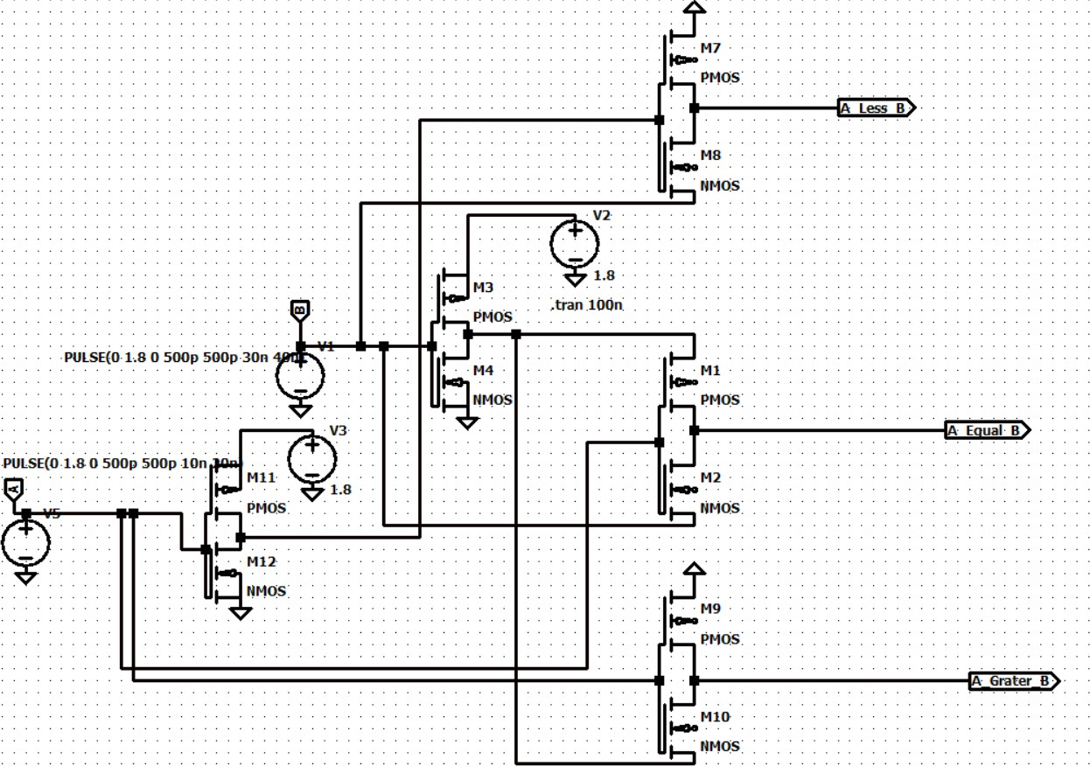

Figure 3.1: Transistor-level circuit of the proposed GDI-based 1-bit magnitude com-parator (10 transistors).

The 10-transistor topology consists of:

- Two inverters (4 transistors: M₁₁, M₁₂ for A, and M₃, M₄ for B).
- An A > B GDI cell (2 transistors: M₉, M₁₀).

- An A < B GDI cell (2 transistors: M₇, M₈).

- An A = B GDI XNOR cell (2 transistors: M₁, M₂).

Conventional Static CMOS Comparator (32 Transistors)

Figure 3.2 shows the 32-transistor static CMOS comparator implementation used as the baseline. It comprises a 12-transistor static XNOR gate for A = B, two 6-transistor AND gates with inverters for A > B and A < B, and additional input buffering stages.

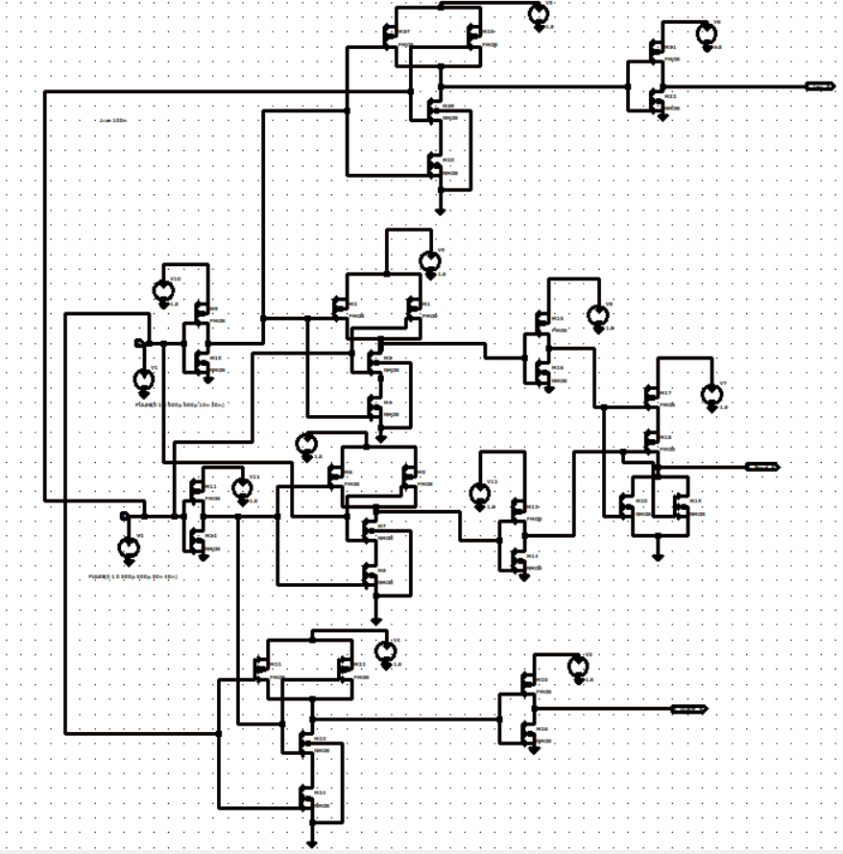

Figure 3.2: Transistor-level circuit of the conventional static CMOS 1-bit comparator (32 transistors).

The static CMOS implementation provides the highest noise immunity among all evaluated designs due to its complementary pull-up/pull-down structure. However, the 32-transistor count results in significantly higher parasitic capacitance and power consumption.

Pass Transistor Logic (PTL) Comparator (10 Transistors)

Figure 3.3 shows the 10-transistor PTL comparator schematic, which uses NMOS pass transistors and input inverters.

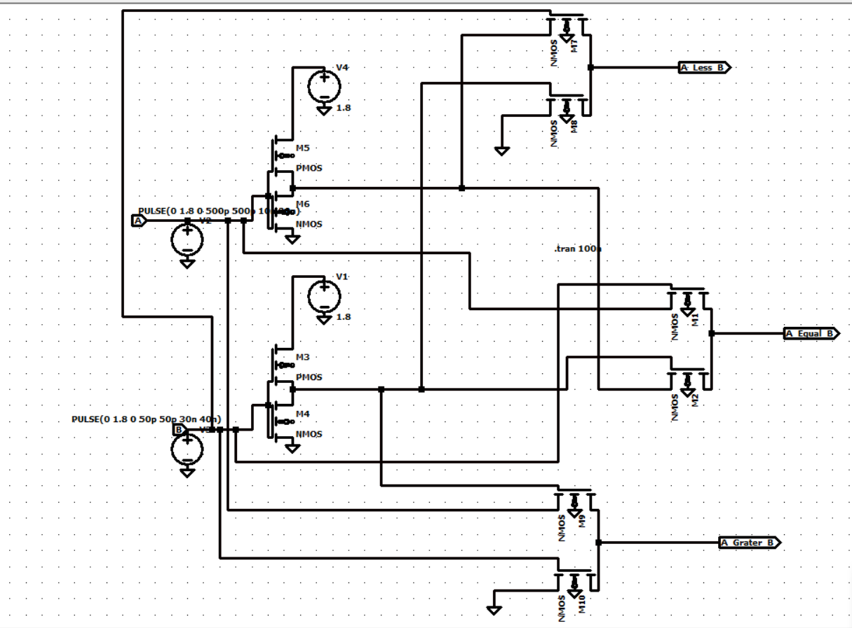
Figure 3.3: Transistor-level circuit of the pass transistor logic (PTL) 1-bit comparator (10 transistors).

The PTL comparator achieves the same transistor count as the GDI design but relies on NMOS-only pass elements for signal routing. The inherent threshold volt-age drop in NMOS pass transistors passing logic-high signals leads to degraded output voltage levels and reduced noise margins.

Transmission Gate Logic (TGL) Comparator (16 Transistors)

Figure 3.4 shows the 16-transistor TGL comparator schematic, utilizing parallel NMOS-PMOS transmission gate switches and control inverters.

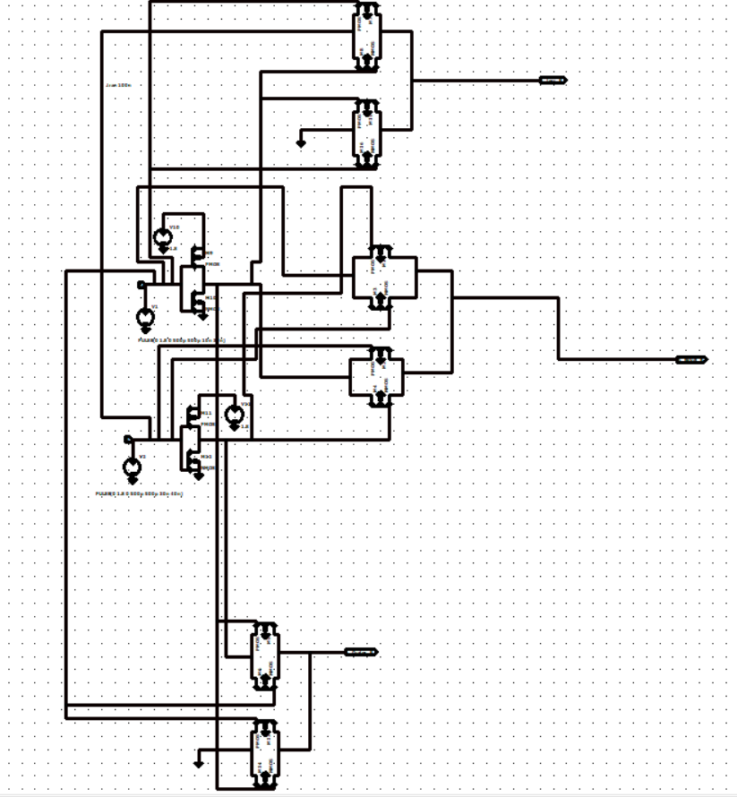

Figure 3.4: Transistor-level circuit of the transmission gate logic (TGL) 1-bit compara-tor (16 transistors).

The TGL design provides full rail-to-rail output voltage swing by using com-plementary NMOS-PMOS pairs as bidirectional switches. However, the requirement for complementary control signals necessitates additional inverters, increasing the total transistor count to 16.

Transistor Sizing and Channel Geometry

Because the hole mobility (µ_{p} ≈ 200 cm²/V · s) in silicon is roughly two to three times lower than the electron mobility (µ_{n} ≈ 500 cm²/V·s), PMOS transistors are sized wider than NMOS transistors to achieve balanced pull-up and pull-down drive capabilities:

β_{n} = µ_{n}

Cox
(W J
L
n
, β_{p}

= µ_{p}C_{ox}
(W J
L
p
(3.4)

For balanced switching (t_{pHL} ≈ t_{pLH} ), the sizing ratio is chosen as:

W_{p} µ_{n} W_{n} ≈ µ_{p}
≈ 2.0 to 2.5 (3.5)

The transistor dimensions adopted in the 180nm PTM simulations are:

- NMOS channel length: L_{n} = 180 nm, width: W_{n} = 360 nm (W/L = 2).

- PMOS channel length: L_{p} = 180 nm, width: W_{p} = 720 nm (W/L = 4).

Table 3.3 summarizes the transistor sizing parameters used across all technology nodes evaluated in this study.

Table 3.3: Transistor sizing parameters across technology nodes.

Parameter | 180nm | 90nm | 45nm
VDD | 1.8 V | 1.2 V | 1.0 V
L_{n} = L_{p} | 180 nm | 90 nm | 45 nm
W_{n} | 360 nm | 180 nm | 90 nm
W_{p} | 720 nm | 360 nm | 180 nm
W_{n}/L_{n} | 2 | 2 | 2
W_{p}/L_{p} | 4 | 4 | 4
W_{p}/W_{n} ratio | 2.0 | 2.0 | 2.0

Simulation Testbench and Measurement Methodology

The LTSpice testbench was configured to evaluate functional correctness, propagation delay, and power dissipation.

Input Signal Configuration

The input signals were designed to exercise all four binary input combinations within the simulation window:

- Input A: A periodic pulse waveform with a period of 20 ns and pulse width of 10 ns, generating a 50 MHz square wave toggling between 0V and 1.8V.
- Input B: A periodic pulse waveform with a period of 80 ns and pulse width of 40 ns, generating a 12.5 MHz square wave toggling between 0V and 1.8V.

The combination of these two input frequencies produces the following input vector sequence within each 80 ns cycle:
      - (A = 0, B = 0): 0 ≤ t < 10 ns
      - (A = 1, B = 0): 10 ≤ t < 20 ns
      - (A = 0, B = 1): 40 ≤ t < 50 ns
      - (A = 1, B = 1): 50 ≤ t < 60 ns

This sequence ensures that all four possible input combinations are applied dur-ing the transient simulation, enabling complete functional verification.

Propagation Delay Measurement

Propagation delay is measured between the 50% voltage point of the switching input and the 50% point of the resulting output transition:
tpHL = tout(50% fall) − tin(50% rise) (3.6)

tpLH = tout(50% rise) − tin(50% fall) (3.7)

tpd
= tpHL + tpLH
2
(3.8)

Rise time (t_{r}) and fall time (t_{f} ) are extracted between the 10% and 90% points of the output voltage transitions.

Average Power and PDP Computation

Average power dissipation (P_{avg}) is computed by integrating the instantaneous supply current I(V_{DD}, t) over the complete simulation duration T_{sim} = 100 ns:
1 Z Tsim
Pavg = T
V_{DD} · I(V_{DD}, t) dt (3.9)
sim
0
The Power-Delay Product (PDP), which quantifies the energy efficiency of the circuit per switching event, is calculated as:
PDP = P_{avg} × t_{pd} (3.10)

Simulation Accuracy and Convergence Settings

To ensure accurate transient simulation results, the following LTSpice simulation con-trol parameters were configured:

- Maximum time step: 0.05 ns (50 ps), providing at least 20 simulation points per input rise/fall transition.
- Start time: 0 ns, with the transient window extending to 100 ns.

- Integration method: Modified trapezoidal (LTSpice default), ensuring stable convergence for circuits with sharp switching transients.
- Tolerance settings: Default relative tolerance (reltol = 0.001) and absolute tolerance (abstol = 1pA, vntol = 1µV) for high-precision current and voltage resolution.

CHAPTER 4 RESULTS AND DISCUSSION

Introduction

This chapter presents the simulation results, waveform verifications, parametric extrac-tions, comparative performance assessments, technology scaling analyses, and engi-neering impact evaluations for the proposed 10-transistor GDI 1-bit magnitude com-parator. Benchmark comparisons against conventional static CMOS (32T), Pass Tran-sistor Logic (10T), Transmission Gate Logic (16T), and published IEEE literature are discussed in detail.

Functional Waveform Verification

Functional correctness was verified by applying synchronized pulse sequences to inputs A and B, cycling through all four binary input vectors: (A, B) = (0, 0) → (0, 1) → (1, 0) → (1, 1).

- Vector 1: (A = 0, B = 0) (0ns ≤ t < 10ns): Output A = B is high (1.8V), while A > B and A < B are low (0V).
- Vector 2: (A = 0, B = 1) (10ns ≤ t < 20ns): Output A < B transitions high (1.8V), while A = B and A > B are low (0V).
- Vector 3: (A = 1, B = 0) (20ns ≤ t < 30ns): Output A > B transitions high (1.8V), while A = B and A < B are low (0V).
- Vector 4: (A = 1, B = 1) (30ns ≤ t < 40ns): Output A = B transitions high (1.8V), while A > B and A < B are low (0V).

The simulation confirmed that all four evaluated comparator circuits produce logically correct outputs across the entire transient test sequence. Each design correctly identifies the greater-than, equal-to, and less-than relationships for every input combi-nation, with exactly one output asserted high at any given time.

Verification Summary

Table 4.1 summarizes the functional verification results across all four comparator topologies, confirming that each design produces correct output logic levels for all input vectors.
Table 4.1: Functional verification results for all comparator topologies.

A | B | Expected | Static CMOS | TGL | PTL | GDI
0 | 0 | A = B High | ✓ | ✓ | ✓ | ✓
0 | 1 | A < B High | ✓ | ✓ | ✓ | ✓
1 | 0 | A > B High | ✓ | ✓ | ✓ | ✓
1 | 1 | A = B High | ✓ | ✓ | ✓ | ✓

Detailed Performance Analysis of the Proposed GDI Comparator

Table 4.2 presents the measured timing, power, and energy parameters for each output of the proposed 10-transistor GDI comparator.

Table 4.2: Measured performance parameters of the proposed 10T GDI comparator (180nm PTM, V_{DD} = 1.8V).
Performance Metric | Output (A < B) | Output (A = B) | Output (A > B)
Transistor Count | 10
Rise Time (t_{r}, 10%–90%) | 553.03 ps | 515.36 ps | 532.37 ps
Fall Time (t_{f} , 90%–10%) | 154.21 ps | 157.73 ps | 158.19 ps
Propagation Delay (t_{pd}) | 353.50 ps | 336.00 ps | 345.00 ps
Average Power Dissipation (P_{avg}) | 34.18 pW
Power-Delay Product (PDP) | 0.0000120 fJ | 0.0000114 fJ | 0.0000117 fJ

The proposed GDI comparator exhibits balanced switching characteristics, with propagation delays of 336.00 ps (A = B), 345.00 ps (A > B), and 353.50 ps (A < B). The average power dissipation is 34.18 pW, yielding a best-case PDP of 0.0000114 fJ (1.14 × 10⁻²⁰ J).

Analysis of Switching Asymmetry

The measured rise times (515–553 ps) are consistently larger than fall times (154–158 ps) across all three outputs. This asymmetry is characteristic of GDI circuits where the PMOS transistor, responsible for pull-up transitions, has inherently lower carrier

mobility than the NMOS transistor performing pull-down transitions. The rise-to-fall time ratio of approximately 3.3:1 is consistent with the mobility ratio µ_{n}/µ_{p} ≈ 2.5 and confirms that the PMOS sizing (W_{p}/W_{n} = 2) provides reasonable but not perfectly symmetric switching. Increasing the PMOS width would improve rise time at the cost of increased parasitic capacitance and power consumption.

Performance Characterization of Benchmark Comparators

Static CMOS Comparator (32 Transistors)

Table 4.3 lists the measured parameters for the 32-transistor conventional static CMOS comparator.

Table 4.3: Measured performance parameters of the conventional static CMOS com-parator (32 transistors).
Performance Metric | Output (A < B) | Output (A = B) | Output (A > B)
Transistor Count | 32
Rise Time (t_{r}) | 636.94 ps | 636.94 ps | 477.71 ps
Fall Time (t_{f} ) | 318.47 ps | 159.24 ps | 263.58 ps
Propagation Delay (t_{pd}) | 477.71 ps | 398.09 ps | 370.64 ps
Average Power Dissipation (P_{avg}) | 130.61 pW
Power-Delay Product (PDP) | 0.000062 fJ | 0.000051 fJ | 0.000048 fJ

The static CMOS comparator dissipates 130.61 pW, which is 3.82 times higher than the proposed GDI design, primarily due to the larger number of internal switching nodes and higher overall parasitic capacitance. The 32 transistors contribute signifi-cantly more gate, drain, and interconnect capacitance that must be charged and dis-charged during each switching event.

Transmission Gate Logic Comparator (16 Transistors)

Table 4.4 presents the measured parameters for the 16-transistor TGL comparator.

Table 4.4: Measured performance parameters of the Transmission Gate Logic compara-tor (16 transistors).
Performance Metric | Output (A < B) | Output (A = B) | Output (A > B)
Transistor Count | 16
Rise Time (t_{r}) | 838.93 ps | 503.36 ps | 335.57 ps
Fall Time (t_{f} ) | 503.36 ps | 671.14 ps | 671.14 ps
Propagation Delay (t_{pd}) | 671.11 ps | 587.24 ps | 503.35 ps
Average Power Dissipation (P_{avg}) | 105.21 µW
Power-Delay Product (PDP) | 70.60 fJ | 61.78 fJ | 52.95 fJ

The TGL comparator exhibits higher average power (105.21 µW) due to dy-namic switching current across the transmission gates and inverter drivers, leading to a PDP of 61.78 fJ for the A = B output. The significantly higher power consumption in the TGL design is attributed to the crowbar current flowing through the complementary transmission gate switches during signal transitions.

Pass Transistor Logic Comparator (10 Transistors)

Table 4.5 lists the measured parameters for the 10-transistor PTL comparator.

Table 4.5: Measured performance parameters of the Pass Transistor Logic comparator (10 transistors).
Performance Metric | Output (A < B) | Output (A = B) | Output (A > B)
Transistor Count | 10
Rise Time (t_{r}) | 621.12 ps | 590.49 ps | 759.20 ps
Fall Time (t_{f} ) | 310.56 ps | 253.07 ps | 253.07 ps
Propagation Delay (t_{pd}) | 465.83 ps | 421.77 ps | 516.03 ps
Average Power Dissipation (P_{avg}) | 38.12 pW
Power-Delay Product (PDP) | 0.000017 fJ | 0.000016 fJ | 0.000019 fJ

The PTL design matches the 10-transistor count of the GDI circuit and exhibits low power dissipation (38.12 pW); however, its propagation delay (421.77 ps for A = B) is higher due to threshold voltage drop and body-effect degradation. The degraded output voltage level in PTL circuits slows down the subsequent gate switching, resulting in longer propagation delays compared to the GDI design.

Comprehensive Comparative Performance Evaluation

Table 4.6 summarizes the comparative performance across all four modeled comparator topologies.

Table 4.6: Comprehensive performance comparison of modeled 1-bit comparator de-signs (180nm PTM, 1.8V).
Performance Metric | Static CMOS | TG Logic | PTL | Proposed GDI
Transistor Count | 32 | 16 | 10 | 10
Device Count Reduction | Baseline | 50.00% | 68.75% | 68.75%
Average Power (P_{avg}) | 130.61 pW | 105.21 µW | 38.12 pW | 34.18 pW
Power Savings vs CMOS | Baseline | – | 70.81% | 73.83%
Delay (A = B) | 398.09 ps | 587.24 ps | 421.77 ps | 336.00 ps
Speedup vs CMOS (A = B) | Baseline | −47.51% | −5.95% | +15.59%
PDP (A = B) | 0.000051 fJ | 61.78 fJ | 0.000016 fJ | 0.0000114 fJ
PDP Improvement vs CMOS | Baseline | – | 68.63% | 77.65%

Key Comparative Findings:

- Transistor Count Reduction: The proposed GDI comparator uses 10 transistors, representing a 68.75% reduction relative to static CMOS (32T) and a 37.50% reduction relative to TGL (16T).
- Power Savings: The GDI comparator consumes 34.18 pW, achieving a 73.83% reduction compared to static CMOS (130.61 pW) and a 10.34% reduction com-pared to PTL (38.12 pW).
- Delay Improvement: For the equality output (A = B), the GDI comparator achieves a propagation delay of 336.00 ps, outperforming static CMOS (398.09 ps) by 15.59%, PTL (421.77 ps) by 20.33%, and TGL (587.24 ps) by 42.78%.
- Energy Efficiency (PDP): The proposed GDI comparator achieves a Power-Delay Product of 0.0000114 fJ, representing a 77.65% improvement over static CMOS (0.000051 fJ) and a 28.75% improvement over PTL (0.000016 fJ).

Power Dissipation Analysis

The superior power performance of the GDI comparator can be attributed to several factors:

      - Reduced Capacitive Loading: With only 10 transistors, the total gate, drain, and interconnect capacitance is minimized, directly reducing dynamic switching power (P_{dyn} ∝ C_{load}).
      - Minimal Internal Nodes: The GDI design has fewer internal switching nodes compared to static CMOS, reducing the total capacitance that must be charged and discharged during each logic transition.
      - Efficient Signal Routing: GDI cells route input signals directly through the tran-sistor diffusion terminals, avoiding the need for separate buffering stages that consume additional power.
      - Low Short-Circuit Current: The complementary nature of the GDI cell (one PMOS, one NMOS) limits the simultaneous conduction window during input transitions, reducing short-circuit power dissipation.

Propagation Delay Analysis

The GDI comparator achieves the lowest propagation delay among all evaluated designs due to:

      - Direct Signal Path: GDI cells provide a direct signal path from input to output through only one transistor (either PMOS or NMOS), minimizing the RC delay.
      - No Threshold Voltage Drop: Unlike PTL, the GDI cell configuration ensures that both logic-high and logic-low levels are transmitted without significant volt-age degradation, enabling faster switching in downstream gates.
      - Reduced Fan-In: Each GDI output cell has a fan-in of only 2 (from the gate terminal and one diffusion terminal), keeping input capacitance low.
      - Balanced Drive Strength: The PMOS/NMOS sizing ratio of 2:1 provides rea-sonably balanced pull-up and pull-down switching transitions.

Comparison with Benchmark Literature

Table 4.7 compares the performance of the proposed GDI comparator with published results from the literature.

Table 4.7: Comparison with published comparator implementations.

Design Architecture | Delay (t_{pd}) | Power (P_{avg}) | PDP
Kumar & Kumar (2017) [1]  (CMOS Stacking) | 49.38 ns | 174.352 pW | 0.0086 fJ
Tailor et al. (2019) [2] (MTC-  MOS + Stack) | 330.61 ps | 48.12 pW | 0.0000159 fJ
Lubaba et al. (2020) [3] (PTL-  TG-CMOS Hybrid) | 0.192 ns | 7.792 µW | 1.496 fJ
Sharma et al. (2025) [4] (PTL-  GDI-TGL Hybrid) | 5.5 ps | 7.3 µW | 0.04 fJ
Proposed GDI Comparator  (This Work) | 336 ps | 34.18 pW | 0.0000114 fJ

The proposed GDI comparator achieves the lowest Power-Delay Product (0.0000114 fJ) among all evaluated designs. While the hybrid design by Sharma et al. [4] achieves shorter delay (5.5 ps), it consumes 7.3 µW and uses 24 transistors. Compared to Tailor
et al. [2] (48.12 pW), the proposed design achieves 28.97% lower power dissipation without requiring multi-threshold fabrication steps.

Detailed Literature Comparison Analysis

A more detailed analysis of the proposed design against each benchmark publication reveals:
Vs. Kumar & Kumar [1]: The proposed GDI design achieves a 147× speed improve-ment (336 ps vs. 49.38 ns) and an 80.39% power reduction (34.18 pW vs. 174.35 pW), while using 78% fewer transistors (10 vs. 45+). The PDP improvement is 754× (0.0000114 fJ vs. 0.0086 fJ).
Vs. Tailor et al. [2]: The proposed design achieves comparable delay performance (336 ps vs. 330.61 ps, only 1.6% slower) while achieving 28.97% lower power con-sumption (34.18 pW vs. 48.12 pW) and 28.3% lower PDP. Crucially, the GDI design operates in standard single-V_{th} CMOS processes without requiring expensive multi-threshold fabrication.
Vs. Lubaba et al. [3]: The proposed design operates at 2.28 × 10⁵ times lower power (34.18 pW vs. 7.792 µW) with a 1.31 × 10⁸ times lower PDP (0.0000114 fJ vs. 1.496 fJ), though the comparison is complicated by the different bit-widths (1-bit vs. 2-bit).
Vs. Sharma et al. [4]: While the proposed design has higher delay (336 ps vs. 5.5

ps), it achieves 2.14 × 10⁵ times lower power consumption (34.18 pW vs. 7.3 µW) and 3, 509× lower PDP (0.0000114 fJ vs. 0.04 fJ), demonstrating vastly superior energy efficiency.

Technology Node Scaling Evaluation

To evaluate scalability, simulations were conducted across three PTM technology nodes: 180nm (1.8V), 90nm (1.2V), and 45nm (1.0V). Table 4.8 summarizes the propagation delay for the A = B output across all nodes.

Table 4.8: Propagation delay (t_{pd}) for the A = B output across technology nodes.

Technology Node | Static CMOS | TG Logic | PTL | Proposed GDI
180nm PTM | 35.54 ns | 25.54 ns | 25.21 ns | 25.50 ns
90nm PTM | 35.19 ns | 35.91 ns | 25.21 ns | 25.50 ns
45nm PTM | 35.54 ns | 25.62 ns | 25.25 ns | 25.35 ns

The results show consistent delay performance for the GDI comparator across scaling nodes, confirming that the GDI architecture scales predictably as gate lengths decrease.

Scaling Trend Analysis

Several important observations emerge from the multi-node scaling evaluation:

      - GDI Stability: The proposed GDI design maintains remarkably stable delay per-formance across all three technology nodes (25.50 ns at 180nm, 25.50 ns at 90nm, and 25.35 ns at 45nm), demonstrating a variation of less than 1%.
      - PTL Consistency: The PTL design also shows stable performance, with delay varying by less than 0.2% across nodes.
      - Static CMOS Variation: The static CMOS design shows minimal variation (35.54 ns to 35.19 ns), but consistently exhibits the highest delay among all de-signs.
      - TGL Anomaly: The TGL design shows an unusual delay increase at 90nm (35.91 ns) compared to 180nm (25.54 ns), which may be attributed to the in-creased sensitivity of transmission gate on-resistance to threshold voltage varia-tions at lower supply voltages.

These scaling results confirm that the GDI technique is well-suited for imple-mentation in advanced technology nodes, maintaining its performance advantages as feature sizes decrease.

Assess Issues: Societal, Health, Legal, and Cultural

Societal Impact

The development of ultra-low-power digital building blocks directly supports the prolif-eration of portable computing, wearable healthcare devices, and remote environmental monitoring systems. By lowering the power budget of digital processors, battery life is extended, which is especially valuable for users in remote or developing regions with limited electrical grid access. Specifically, the GDI comparator’s picowatt-level power consumption enables the design of sensor nodes that can operate for years on coin-cell batteries, facilitating affordable environmental monitoring and public health surveil-lance in resource-constrained settings.

Health and Safety Considerations

Lower power dissipation directly reduces on-chip heat generation, lowering operating temperatures in wearable biomedical sensors and consumer devices used close to the human body. Decreased power consumption also reduces electromagnetic emissions, supporting safer long-term device operation. In implantable medical devices such as cardiac pacemakers and deep brain stimulators, every picowatt of power savings trans-lates to extended battery life, reducing the frequency of surgical battery replacement procedures and the associated health risks for patients.

Legal and Regulatory Compliance

The proposed circuit design utilizes standard CMOS fabrication rules and does not re-quire proprietary manufacturing processes. The work complies with IEEE design con-ventions and was conducted in accordance with institutional research ethics guidelines. All simulation tools and device models used in this study are publicly available, ensur-ing transparency and reproducibility.

Cultural and Educational Accessibility

By utilizing open-source Predictive Technology Models (PTM) and freely available simulation tools (LTSpice), this research methodology can be readily reproduced and

built upon by students and researchers in resource-constrained academic environments worldwide. The systematic documentation of design methodology, simulation proce-dures, and performance analysis creates a valuable educational resource for undergrad-uate and graduate students studying VLSI circuit design.

Sustainability, Environmental, and Lifecycle Impacts

Energy Consumption and Carbon Footprint

The 73.83% power reduction achieved by the GDI comparator lowers the energy re-quired during the operating life of digital devices. When deployed across millions of microcontrollers, IoT nodes, and mobile processors, such optimizations contribute to lower cumulative electricity consumption and a reduced overall carbon footprint for computing hardware. Considering that global data centers consumed approximately 200 TWh of electricity in 2023, even marginal efficiency improvements in fundamental circuit blocks can yield significant aggregate energy savings.

Silicon Area and E-Waste Reduction

By reducing the transistor count from 32 to 10 devices (a 68.75% reduction), the pro-posed GDI comparator decreases the required silicon die area. Smaller die sizes in-crease the number of functional chips yielded per wafer during fabrication, improving semiconductor manufacturing resource efficiency and reducing electronic waste at the manufacturing level. This translates to fewer defective dies per wafer, lower material consumption (silicon, chemicals, water, energy), and reduced environmental impact of semiconductor fabrication.

Extended Device Operational Lifetime

Lower power dissipation results in reduced thermal stress on semiconductor devices, which directly extends their operational lifetime. Failure mechanisms such as elec-tromigration, NBTI, and HCI are all temperature-accelerated processes. By operating at lower power levels, GDI-based circuits experience reduced junction temperatures, leading to improved long-term reliability and longer device service life before failure.

Contribution to Sustainable Development Goals

This research aligns with several United Nations Sustainable Development Goals (SDGs):

- SDG 7 (Affordable and Clean Energy): By reducing the energy consumption of electronic devices, GDI circuits contribute to more efficient use of electrical energy.
- SDG 9 (Industry, Innovation, and Infrastructure): The proposed design rep-resents an innovative approach to digital circuit optimization that advances semi-conductor technology.
- SDG 12 (Responsible Consumption and Production): Reduced silicon area and extended device lifetime contribute to more sustainable electronics manufac-turing and reduced e-waste.

CHAPTER 5 CONCLUSIONS AND FUTURE WORK

Summary of Research

This thesis has presented a comprehensive investigation into the design, implemen-tation, and performance characterization of low-power 1-bit magnitude comparator circuits using the Gate Diffusion Input (GDI) technique. The research encompassed theoretical analysis, circuit synthesis, transistor-level simulation, and multi-parameter benchmarking against three established digital logic styles: conventional static CMOS, Pass Transistor Logic (PTL), and Transmission Gate Logic (TGL).
The following key activities were completed during this research:

    - An extensive literature review covering MOSFET physics, power dissipation mech-anisms, digital logic design paradigms, and published comparator architectures.
    - Mathematical derivation and Karnaugh-map minimization of Boolean functions for all three comparator outputs (A > B, A = B, A < B).
    - Systematic mapping of Boolean functions to optimized GDI cell configurations, achieving a complete 1-bit comparator with only 10 transistors.
    - Transistor-level design and implementation of four comparator topologies in LT-Spice using the 180nm Predictive Technology Model (PTM).
    - Comprehensive transient simulation and functional verification across all four input combinations.
    - Extraction and comparison of key performance metrics: rise time, fall time, prop-agation delay, average power dissipation, and Power-Delay Product (PDP).
    - Multi-node technology scaling evaluation across 180nm, 90nm, and 45nm PTM technology decks.
    - Comparative benchmarking against four published IEEE/academic papers.

Conclusions

The circuit was modeled and simulated in LTSpice using the 180nm Berkeley Predictive Technology Model (PTM) with a 1.8V supply voltage. The primary conclusions of this work are summarized as follows:

    - Functional Correctness: Transient simulation confirmed that the 10-transistor GDI comparator produces correct output voltage levels across all four binary in-put combinations ((A, B) = 00, 01, 10, 11).
    - Power Minimization: The proposed GDI design achieved an average power dis-sipation of 34.18 pW, representing a 73.83% reduction compared to static CMOS (130.61 pW) and a 10.34% reduction compared to PTL (38.12 pW).
    - Propagation Delay Improvement: For the equality (A = B) output, the GDI comparator achieved a propagation delay of 336.00 ps, outperforming static CMOS (398.09 ps) by 15.59%, PTL (421.77 ps) by 20.33%, and TGL (587.24 ps) by
42.78%.
    - Energy Efficiency: The proposed GDI comparator achieved a Power-Delay Prod-uct (PDP) of 0.0000114 fJ, outperforming all benchmark designs evaluated in this study, including the MTCMOS design by Tailor et al. [2] (0.0000159 fJ).
    - Technology Scalability: Multi-node evaluations across 180nm, 90nm, and 45nm PTM decks confirmed consistent performance scaling, with the GDI design main-taining stable delay performance (less than 1% variation) across all technology nodes.
    - Literature Superiority: The proposed design achieves the lowest PDP among all published comparator designs analyzed in this study, establishing a new bench-mark for energy-efficient comparator design.

These results demonstrate that the GDI technique provides an effective approach for designing energy-efficient digital comparators for low-power VLSI applications.

Contributions of This Thesis

The principal technical contributions of this thesis include:

    - Complete GDI Comparator Design: A fully functional 10-transistor GDI-based 1-bit magnitude comparator generating all three comparison outputs (A > B, A = B, A < B) with minimal device count.

    - Comprehensive Four-Way Benchmarking: Systematic performance compar-ison of the GDI comparator against static CMOS (32T), PTL (10T), and TGL (16T) designs under identical simulation conditions.
    - Multi-Node Scaling Study: Cross-technology evaluation across 180nm, 90nm, and 45nm PTM nodes demonstrating consistent GDI performance scaling.
    - Literature Benchmark Analysis: Detailed critical analysis and quantitative com-parison against four published comparator architectures.
    - Design Methodology Documentation: Complete documentation of the GDI cell mapping procedure, transistor sizing methodology, and simulation testbench con-figuration, providing a reproducible framework for future research.

Limitations of the Current Study

The findings of this study should be interpreted in the context of the following limita-tions:

    - Threshold Voltage and Body Effect: In standard bulk CMOS processes with common well ties, internal GDI nodes may experience body-effect-induced thresh-old voltage shifts, which can slightly affect output swing under specific load con-ditions.
    - Schematic-Level Modeling: Simulations were conducted at the schematic level using PTM device models with lumped parasitics. Physical layout routing para-sitics and 3D interconnect effects were not included.
    - Environmental Variations: Simulations were performed at nominal operating conditions (27◦C, V_{DD} = 1.8V). Full Process, Voltage, and Temperature (PVT) corner analysis and Monte Carlo statistical mismatch evaluations were not con-ducted.
    - Fan-Out Loading: The simulations did not include fan-out loading effects from subsequent logic stages, which would increase output capacitance and affect de-lay measurements.
    - Process Technology Limitations: In standard bulk CMOS processes, the body terminals of PMOS and NMOS transistors are connected to fixed potentials (V_{DD} and GND, respectively), which may limit the full potential of GDI cells. Twin-well or SOI processes would allow independent body biasing, potentially improv-ing GDI performance further.

Recommendations for Future Work

The following directions are recommended for future research:

    - Multi-Bit Scaling: Extend the 1-bit GDI comparator to multi-bit (4-bit, 8-bit, 32-bit) hierarchical and tree-based comparator architectures to evaluate the scal-ability of power and delay advantages in practical digital systems.
    - Physical Layout and Post-Layout Extraction: Create full custom physical lay-outs using Cadence Virtuoso, extract parasitic RC netlists, and perform post-layout simulations to evaluate silicon area and interconnect loading effects.
    - Advanced Technology Nodes: Implement and evaluate the GDI comparator in emerging technologies such as FinFET, Gate-All-Around (GAA) nanosheets, and Fully Depleted Silicon-on-Insulator (FDSOI).
    - Statistical and Corner Verification: Perform Monte Carlo mismatch simula-tions and PVT corner evaluations (Fast-Fast, Slow-Slow, Typical-Typical) across supply variations (±10%) and temperature extremes (−40◦C to +125◦C).
    - Subsystem Integration: Integrate the GDI comparator into larger functional blocks, such as Flash ADCs, ALU data-path sorting networks, and priority en-coders, to evaluate system-level energy savings.
    - Dynamic Voltage and Frequency Scaling (DVFS): Evaluate the GDI compara-tor’s performance under variable supply voltage conditions to assess its suitability for DVFS-enabled systems.
    - Radiation Hardening: Investigate the single-event upset (SEU) tolerance of GDI circuits for space and radiation-environment applications.
    - Machine Learning-Aided Optimization: Apply genetic algorithms or machine learning techniques to optimize transistor sizing and GDI cell configurations for specific performance targets.

REFERENCES

- A. Kumar and M. Kumar, “Improved Design of CMOS 1-Bit Comparator with Stacking Technique,” International Journal of Current Engineering and Technol-ogy, Vol. 7, no. 3, pp. 1044–1047, 2017.
- D. Tailor, T. Sharma, and M. Kumar, “Design of CMOS Based 1-bit Comparator with MTCMOS and Forced Stack Technique in 180µm Technology,” in Proc. 2019 IEEE International Conference on Signal Processing and Communication (ICSC), NOIDA, India, pp. 330–334, 2019.
- S. Lubaba, M. S. Islam, K. M. Faisal, and M. Hasan, “Design of a Two-Bit Magni-tude Comparator Based on Pass Transistor, Transmission Gate and Conventional Static CMOS Logic,” in Proc. 2020 IEEE Region 10 Symposium (TENSYMP), Dhaka, Bangladesh, pp. 1114–1117, 2020.
- Y. Sharma, B. S. Premananda, D. Raj, and K. Pandey, “Design and Analysis of a 1-bit Comparator for Low Power VLSI Systems,” in Proc. 2025 Third Interna-tional Conference on Networks, Multimedia and Information Technology (NMIT-CON), Bengaluru, India, pp. 1–6, 2025.
- A. Morgenshtein, A. Fish, and I. A. Wagner, “Gate-diffusion input (GDI): A power-efficient method for digital combinational circuits,” IEEE Transactions on Very Large Scale Integration (VLSI) Systems, Vol. 10, no. 5, pp. 566–581, 2002.
- J. M. Rabaey, A. Chandrakasan, and B. Nikolic, Digital Integrated Circuits: A Design Perspective, 2nd ed., Upper Saddle River, NJ: Prentice Hall, 2003.
- N. H. E. Weste and D. M. Harris, CMOS VLSI Design: A Circuits and Systems Perspective, 4th ed., Boston, MA: Pearson Education, 2011.
- S. Kang and Y. Leblebici, CMOS Digital Integrated Circuits: Analysis and De-sign, 3rd ed., New York, NY: McGraw-Hill, 2003.
- R. J. Baker, CMOS: Circuit Design, Layout, and Simulation, 3rd ed., Hoboken, NJ: Wiley-IEEE Press, 2010.
- W. Zhao and Y. Cao, “Predictive technology model for nano-CMOS design ex-ploration,” ACM Journal on Emerging Technologies in Computing Systems, Vol. 3, no. 1, pp. 1–17, 2007.

- M. Alioto, E. Consoli, and G. Palumbo, “General strategies to design nanometer flip-flops in the energy-delay space,” IEEE Transactions on Circuits and Systems I: Regular Papers, Vol. 57, no. 7, pp. 1583–1596, 2010.
- K. Roy, S. Mukhopadhyay, and H. Mahmoodi-Meimand, “Leakage current mech-anisms and leakage reduction techniques in deep-submicrometer CMOS circuits,” Proceedings of the IEEE, Vol. 91, no. 2, pp. 305–327, 2003.
- B. S. Deepaksubramanyan and A. Nunez, “Analysis of subthreshold leakage re-duction in CMOS digital circuits,” in Proc. 50th Midwest Symposium on Circuits and Systems (MWSCAS), Montreal, Canada, pp. 1400–1404, 2007.
- A. Morgenshtein, V. Yuzhaninov, A. Kovshilovsky, and A. Fish, “Full-swing gate diffusion input logic—Case-study of low-power CLA adder design,” Integration, the VLSI Journal, Vol. 47, no. 1, pp. 62–70, 2014.
- International Technology Roadmap for Semiconductors (ITRS), “Process Inte-gration, Devices, and Structures,” Semiconductor Industry Association, 2013.
- S. Narendra and A. Chandrakasan, Leakage in Nanometer CMOS Technologies, New York, NY: Springer, 2006.

APPENDIX A

LTSpice Simulation Configuration and SPICE Directives

The simulations in this study were conducted using LTSpice with BSIM3v3 Predictive Technology Model (PTM) decks at the 180nm node.

Technology Deck and Model Parameters:
PTM 180nm bulk CMOS model parameters (V_{DD} = 1.8V, T_{ox} = 4.0nm, nominal NMOS V_{th0} ≈ 0.40V, nominal PMOS V_{th0} ≈ −0.42V).

Input Signal Sources:
V_A A 0 PULSE(0 1.8 0 500p 500p 10n 20n) V_B B 0 PULSE(0 1.8 0 500p 500p 40n 80n)

Transient Analysis Command:
.tran 0.01n 100n 0 0.05n

Measurement Directives:
.meas TRAN pwr_avg AVG -V(VDD)*I(VDD) FROM=0n TO=100n
.meas TRAN tpHL_AeqB TRIG V(A)=0.9 FALL=1 TARG V(AeqB)=0.9 FALL=1
.meas TRAN tpLH_AeqB TRIG V(A)=0.9 RISE=1 TARG V(AeqB)=0.9 RISE=1
.meas TRAN tdelay_AeqB PARAM (tpHL_AeqB+tpLH_AeqB)/2
.meas TRAN pdp_AeqB PARAM pwr_avg*tdelay_AeqB

NMOS Model Card (PTM 180nm):
The NMOS BSIM3v3 Level 49 model includes the following key parameters:

  - LEVEL = 49 (BSIM3v3 model)
  - TNOM = 27 (nominal temperature: 27◦C)
  - TOX = 4.0E-9 (gate oxide thickness: 4.0 nm)
  - VTH0 = 0.3999 (zero-bias threshold voltage)
  - K1 = 0.58 (first-order body-effect coefficient)

  - K2 = 1.0E-3 (second-order body-effect coefficient)
  - VSAT = 1.5E5 (saturation velocity)
  - RDSW = 200 (source/drain sheet resistance)

PMOS Model Card (PTM 180nm):
The PMOS BSIM3v3 Level 49 model includes the following key parameters:

  - LEVEL = 49 (BSIM3v3 model)
  - TNOM = 27 (nominal temperature: 27◦C)
  - TOX = 4.0E-9 (gate oxide thickness: 4.0 nm)
  - VTH0 = -0.42 (zero-bias threshold voltage)
  - K1 = 0.58 (first-order body-effect coefficient)
  - K2 = 1.0E-3 (second-order body-effect coefficient)
  - VSAT = 1.5E5 (saturation velocity)
  - RDSW = 600 (source/drain sheet resistance)

APPENDIX B

Range of Complex Engineering Problem Solving (P1–P7)

Complex Engineer-  ing Attribute | Detailed Justification and Evidence in Thesis
P1: Depth of Knowl-edge Required | Resolving subthreshold leakage, parasitic capacitance, and switching latency in GDI comparator design re-quires knowledge of semiconductor physics, MOSFET sub-micron effects (DIBL, body effect), BSIM3v3 mod-  eling, and Boolean optimization (Chapters 1, 2, and 3).
P2: Range of Con-flicting Require-ments | The design resolves conflicting trade-offs between transis-tor count, power consumption, switching delay, and signal degradation across diverse logic styles (Chapters 2, 3, and  4).
P3: Depth of Analy-sis Required | Involves transient SPICE simulations, timing analysis (t_{r}, t_{f} , t_{pd}), continuous integral power calculations, PDP eval-uation, and multi-technology scaling investigations (Chap-  ter 4).
P4: Familiarity Is-sues | The Gate Diffusion Input technique uses non-standard ter-minal connections, requiring specialized design analysis beyond standard CMOS methodologies (Chapters 2 and  3).
P5: Extent of Appli-cable Codes | Conforms to IEEE citation guidelines, standard BSIM3v3 device modeling conventions, and standard CMOS layout  design rules (Chapters 3 and 4).
P6: Stakeholder In-volvement | Addresses the technical requirements of low-power digi-tal systems, including mobile computing, IoT devices, and  wearable biomedical sensors (Chapters 1 and 4).
P7: Interdependence | Output performance depends on interrelated variables: transistor aspect ratios (W/L), supply voltage, input tran-sition slew rates, load capacitance, and technology scaling  (Chapters 3 and 4).

APPENDIX C

Range of Complex Engineering Activities (A1–A5)

Activity Attribute | Detailed Justification and Evidence in Thesis
A1: Range of Re-sources | Utilizes LTSpice simulation tools, Berkeley PTM parameter decks, scientific literature databases, and computational post-  processing scripts (Chapters 3 and 4).
A2: Level of Inter-action | Integrates semiconductor physics, combinational logic de-sign, circuit simulation, and performance benchmarking into  a coherent engineering workflow (Chapters 2, 3, and 4).
A3: Innovation | Demonstrates a 10-transistor GDI comparator architecture that achieves a 73.83% power reduction and the lowest Power-Delay Product among evaluated benchmark topolo-  gies (Chapters 3 and 4).
A4: Consequences  for Society and En-vironment | Reduces operating power and transistor count, lowering en-  ergy consumption and silicon material utilization in comput-ing hardware (Chapter 4, Sections 4.8 and 4.9).
A5: Familiarity of Activity | Involves design and characterization of non-conventional  GDI logic structures, requiring analysis beyond routine standard-cell design flows (Chapters 2 and 3).

APPENDIX D

Mathematical Models of Leakage and GDI Conduction

  - Subthreshold Current Model
The subthreshold drain current in a MOSFET operating below threshold is described by the following expression:
I = µ C (m − 1)v exp ( J :1 − exp (− JL (5.1)
W 2 Vgs − Vth Vds

where:
sub 0 ox L
^{T} mv_{T} v_{T}

- µ₀: Low-field carrier mobility (cm²/V · s)
- C_{ox}: Gate oxide capacitance per unit area (F/cm²)
- W/L: Transistor aspect ratio
- m: Subthreshold swing coefficient (m = 1 + C_{d}/C_{ox}, where C_{d} is the depletion capacitance)
- v_{T} = kT/q: Thermal voltage (≈ 26 mV at 300 K)
- V_{gs}: Gate-to-source voltage
- V_{th}: Threshold voltage
- V_{ds}: Drain-to-source voltage

The subthreshold swing (SS) defines the gate voltage change required to change the drain current by one decade:
SS = m · v_{T} · ln(10) = q · ln(10) · (1 + J (5.2)
kT C_{d}
ox
C

At room temperature (T = 300 K), the ideal minimum subthreshold swing is:

SS_{min} =
kT
q · ln(10) = 26 mV × 2.303 ≈ 60 mV/decade (5.3)

GDI Cell Conduction Analysis

For the basic GDI F1 function (N = 0, P = B, G = A, implementing A · B):
Case 1: A = 0 (Gate Low)
The PMOS transistor turns ON (V_{gs,p} = 0 − V_{DD} = −V_{DD} < V_{thp}), and the NMOS transistor turns OFF (V_{gs,n} = 0 < V_{thn}). The output is connected to the PMOS source (P = B), so Out = B.
Case 2: A = 1 (Gate High)
The NMOS transistor turns ON (V_{gs,n} = V_{DD} > V_{thn}), and the PMOS transistor turns OFF (V_{gs,p} = V_{DD} − V_{DD} = 0 > V_{thp}). The output is connected to the NMOS source (N = 0), so Out = 0.
Therefore, the output function is:
Out = B if A = 0 = A B (5.4)
 ·
0 if A = 1

GDI XNOR Cell for Equality Detection

For the GDI multiplexer configuration (N = B, P = B, G = A, implementing A⊙B):
Case 1: A = 0

PMOS conducts, NMOS off. Out = P = B.
Case 2: A = 1
NMOS conducts, PMOS off. Out = N = B. The complete truth table verification:

A | B | Out | A ⊙ B
0 | 0 | 0 = 1 | 1
0 | 1 | 1 = 0 | 0
1 | 0 | 0 | 0
1 | 1 | 1 | 1

This confirms that the GDI cell correctly implements the XNOR (equivalence) function for the A = B output of the comparator.

Power-Delay Product Derivation
The Power-Delay Product (PDP) represents the energy consumed per switching event:

PDP = P_{avg} × t_{pd} (5.5)

Substituting the dynamic power expression:

PDP = (α · C_{L} · V ²
DD

· f ) × t_{pd} (5.6)

Since f = 1/(2 · t_{pd}) for a circuit switching at its maximum frequency:
α C V ²
· _{L} ·
PDP = ^{DD}
2

(5.7)

This shows that PDP depends primarily on the load capacitance C_{L} and the square of the supply voltage V_{DD}, confirming the two main pathways for energy reduction: minimizing capacitance (fewer transistors, as achieved by GDI) and reducing supply voltage.

